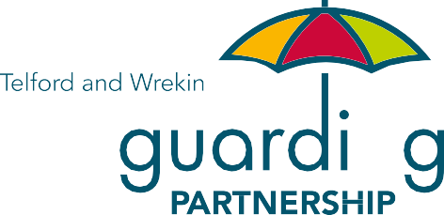

Safeguarding Threshold for Access to Safeguarding Services Matrix

Reviewed August 2024

Introduction

This document has been developed in response to findings from case reviews and audits which have shown the need for better shared understanding of safeguarding by agencies. It provides guidance for professionals and service users, to clarify the circumstances in which Telford & Wrekin Adult Safeguarding Team will assist in safeguarding adults in Telford and Wrekin.

Note: This is a guide and should be used in conjunction with the West Midlands Multi-agency Safeguarding Policies and Procedures. The guide is designed to help you when deciding on the best course of action and you should use your professional judgment in deciding if a real concern is similar to the illustrations below.

Prior to raising an adult safeguarding concern, please consider the following:

1 Does the concern meet the criteria for a Section 42 safeguarding enquiry under the requirements of The Care Act 2014?
You will need to consider the following:
- The adult is reported as having or appears to have needs for care and support (whether or not Telford & Wrekin Council is meeting any of those needs).
- The adult is reported or appears to be experiencing or at risk of abuse or neglect.
- And as a result of care and support needs is the adult unable to protect themselves from either the risk of, or the experience of abuse or neglect.
- Or the Perpetrator is an adult with care and support needs.

2 Has the person given their consent to the information to be shared and do they know a Section 42 enquiry be undertaken? If they lack capacity to consent consider the 5 principles of the Mental Capacity Act and whether a disclosure is required in their best interest. Please note that in exceptional circumstances there may be the need to share a concern without consent. For more information contact the Adult Safeguarding Team – in the first instance without disclosing the person’s name
It is acknowledged that abuse or neglect can take different forms, including the following types of abuse:
- Physical abuse;
- Domestic abuse;
- Sexual abuse;
- Psychological abuse;
- Financial or material abuse;
- Modern slavery;
- Discriminatory abuse;
- Organisational abuse;
- Neglect and acts of omission;
- Self-neglect.
In addition, there are other types of abuse including criminal exploitation e.g. cuckooing (or home invasion or takeover), county lines. For further details on the types of abuse refer to the Adult Safeguarding: Multi-agency policy & procedures for the protection of adults with care & support needs in the West Midlands here

3 Has the person given their consent to the information to be shared and do they know a S42 enquiry will be undertaken? If they lack capacity to consent consider the 5 principles of the Mental Capacity Act and whether a disclosure is required in their best interest
Consent is not essential when deciding whether concerns should be raised. However, wherever possible you should discuss your concerns with the person and/or their representative, and seek their consent, and take into account their views and desired outcomes. Where the person is not willing or able to freely give their consent to information about their circumstances being shared you will need to consider the following:
- To what extent is the person able to make a particular decision or take a particular action for themselves to protect themselves at the time the decision or action needs to be taken?
- Are there any children and/or other adults with care and support needs involved, or is there a potential risk to others?
- Is an advocate required to support the individual?

If the person does not consent to information sharing you may also consider the following factors with them in supporting them to make an informed decision.

- How severe/serious is the harm/potential harm caused?
- What is the impact/potential impact on the person’s independence, health and wellbeing?
- Is the abuse is likely to be repeated or escalate?
- Is there evidence that the person may be subject to intimidation, threats or coercion?

If you remain unsure as to what action to take you should discuss this with your manager or your organisation’s safeguarding lead. Ensure you record all actions clearly with reasons for your decision.

4 The Safeguarding Principles

Principle 1: Empowerment
People should be supported and encourage to make their own decisions. This should be done by:
  - making services more personal;
  - giving people choice and control over decisions; and
  - asking people what they want the outcome to be.

Principle 2: Prevention
Organisations should work together to stop abuse before it happens by:
  - Raising awareness about abuse and neglect;
  - Training staff; and
  - Making sure clear, simple and accessible information is available about abuse and where people can get help.

Principle 3: Proportionality
When dealing with abuse situations services must ensure that they always think about the risk. Any response should be appropriate to the risk presented. Services must respect the person, think about what is best for them and only get involved as much as needed.

Principle 4: Protection
Organisations must ensure that they know what to do when abuse has happened by:
  - What to do if there are concerns;
  - How to stop the abuse; and
  - ` How to offer help and support for people who are at risk.

Principle 5: Partnership
Organisations should work in partnership with each other and local communities. Local people also have a part to play in preventing, detecting and reporting abuse.

Principle 6: Accountability
Safeguarding is everybody’s business. Everyone must accept that we are all accountable as individuals, services and as organisations. Roles and responsibilities must be clear so that people can see and check how safeguarding is done.

Guidance on the categories

Lower Level of Harm – These may not meet the threshold for a section 42 enquiry, however the actions may include advice, information, risk management, staff training, disciplinary or complaints procedures. Any actions taken should be recorded.
However, if there are multiple ‘non-reportable’ incidents concerning the same service user/staff member/team consideration should be given as to whether a safeguarding concern should be raised. It may be advisable to discuss this with the organisational Adult Safeguarding Lead.

Significant – This means that it is likely to meet the threshold for a Section 42 enquiry. A safeguarding concern and consultation with the organisational Adult Safeguarding Lead is advisable.

Critical – This means that it is highly likely to result in an urgent safeguarding enquiry (known as a Section 42 Enquiry). It will be a serious criminal matter, and therefore immediate discussion with the police will be required.

 | Levels of harm and related indicators/examples
Type of abuse | Lower Level Harm | Significant | Critical
Physical Abuse (including Fabricated and Induced Illness) | - Error by staff causing no/little harm, e.g. skin friction mark due to ill-fitting hoist sling.  - Isolated incident by other resident causing no/little harm, e.g. one resident strikes another but it leaves no mark and appears not to cause emotional distress lasting hours.  - Unexplained very light marking/bruising found on one occasion.  - Persuades healthcare professionals that an adult who is dependent on them is ill when they're healthy. | - Unexplained marking or lesions, minor cuts or grip marks on a number of occasions on an individual or a number of individuals cared for by a specific team/carer.  - Inappropriate restraint that causes marks to be left but no external medical treatment/ consultation required.  - Assault by another resident requiring first aid.  - Manipulates test results to suggest an adult who is dependent on them is ill, for example, by putting glucose in urine samples to suggest the adult has diabetes. | - Serious bodily harm/assault with weapon leading to irreversible damage or death.  - Intended harm towards a service user.  - Deliberately withholding of food, drinks or aids to independence.  - Unexplained fractures/serious injuries.  - Assault by another resident requiring acute medical care.  - Deliberately induces symptoms of illness, for example, by poisoning an adult who is dependent on them with unnecessary medicine or other substances.
Psychological Abuse | - Isolated incident where adult is spoken to in a rude or inappropriate way – respect is undermined but no or little distress caused.  - Occasional taunts or verbal outbursts which cause distress. | - Treatment that undermines dignity and damages esteem.  - Repeated incidents of denying or failing to recognize an adult’s choices or of failing to value their opinion, particularly in relation to a service or care they are receiving.  - Occasional taunts or verbal outbursts which do cause distress between service users. | - Denial of basic human rights/ civil liberties, over-riding advance directive, forced marriage.  - Prolonged intimidation.  - Vicious/personalised verbal attacks.  - Humiliation of service user.  - Emotional blackmail e.g. threats of abandonment/harm.  - The withholding of information to dis-empower.

 | Levels of harm and related indicators/examples
Type of abuse | Lower Level Harm | Significant | Critical
Sexual Abuse | Not committed by a person in a position of trust, and:  - Isolated incident of teasing or unwanted attention, either verbal or physical (but excluding genitalia), where the effect on the adult is low.  - Isolated incident of teasing or low-level unwanted sexualised attention (verbal or by gestures) directed at one adult by another whether or not capacity exists – appears no harm or distress caused. | - Non- contact sexualised behaviour which causes distress to the person at risk.  - Verbalised sexualized teasing or harassment.  - Being subject to indecent exposure where the service user appears not to be distressed. | - Any allegation of sexualised behaviour, to include sexual acts in front of an adult or relating to a  person in a position of trust against a person in their care.  - Sex in a relationship characterised by authority, inequality or exploitation,  e.g. staff and service user.  - Sex without valid consent (rape).  - Voyeurism.  - Sexualised touch or masturbation without valid consent.  - Being made to look at pornographic material against will/where valid consent cannot be given.  - Attempted penetration by any means (whether or not it occurs within a relationship) without valid consent.  - Sexting.

 | Levels of harm and related indicators/examples
Type of abuse | Lower Level Harm | Significant | Critical
Domestic Abuse | Service user has no current fears and there are adequate protective factors, and it is:  - One off incident with no injury or harm experienced;  - Occasional taunts or verbal outbursts where the service user has capacity to decide whether to have the case referred on. | - Unexplained marking or lesions or grip marks on a number of occasions.  - Controlling or coercive behaviour is disclosed.  - Frequent verbal outbursts that cause some distress or some level of harm e.g. belittling.  - Sexual assault where the service user has capacity and does not want to be referred.  - Sexual humiliation where the service user has the capacity and does not want to be referred.  - Experiences occasional episodes of fear of the alleged perpetrator.  - Subject to severe controlling behavior e.g. finances/medical. | - Subject to regular violent behaviour.  - Threats or attempts to kill/choke/suffocate etc.  - In constant fear of being harmed.  - Sex without valid consent (rape).  - Female Genital Mutilation (FGM).  - Honour based violence &/or forced marriage.  - Service user denied access to medical treatment/care/ vital equipment to maintain  independence by alleged abuser.  - Frequent physical outburst that cause distress or some level of harm.  - Subject to stalking/harassment.
NB: Where there are children (under 18) in the household, or present when the domestic abuse incident took place (even if not witnessed by the child), the case must be referred into Children’s Safeguarding via Family Connect.

 | Levels of harm and related indicators/examples
Type of abuse | Lower Level Harm | Significant | Critical
Neglect & Acts of Omission (including Fabricated and Induced Illness) | - Isolated missed/late/shortened home care visit - no harm occurs and no other service users/clients is missed that day.  - Adult is not assisted with a meal/drink on one occasion and no harm occurs.  - Inadequacies in care provision leading to discomfort - no significant harm e.g. the adult is left wet or soiled for a period of time.  - An unwitnessed fall that requires no external medical treatment/consultation, i.e. no call to 111 or admissions to hospital.  - Inappropriate infection and prevention control measures with no harm.  - Persuades healthcare professionals that an adult who is dependent on them is ill when they're healthy. | - Recurrent missed/late/shortened home care visits where risk of harm escalates, or one miss where harm occurs.  - Discharge from hospital where harm occurs that does not require re-admission.  - Recurrent lack of care to extent that health and well-being deteriorate e.g. pressure ulcers, dehydration, malnutrition (assessed to the capability of the person reporting).  - Unwitnessed fall where 111 are called and recommend getting external medical treatment  e.g. an ambulance.  - Family knowingly going against prescribed care  e.g. food, medication or equipment.  - Recurrent inappropriate infection and prevention control measures leading to harm.  - Manipulates test results to suggest an adult who is dependent on them is ill, for example, by putting glucose in urine samples to suggest the adult has diabetes. | - Failure to arrange access to life saving services or medical care.  - Willful neglect, failure to intervene in dangerous situations where the adult lacks the capacity to assess risk.  - Discharge from hospital where harm occurs that does require re- admission.  - Paid carer knowingly going against prescribed care, e.g. food medication or equipment.  - Deliberately induces symptoms of illness, for example, by poisoning an adult who is dependent on them with unnecessary medicine or other substances.
Medication Errors | - Isolated incident where the person is accidentally given the wrong medication, given too much or too little medication or given it at the wrong time but no harm occurs.  - Isolated incident causing no harm that is not reported by staff member.  - Isolated prescribing or dispensing error by GP, pharmacist or other medical professional resulting in no harm. | - Recurring missed medication or errors that affect more than one adult and result in actual or potential harm to one or more adults.  - Recurring prescribing or dispensing errors by GP, pharmacist or other medical professional that affect more than one adult and/or result in harm to one or more adults.  - Covert administration without the person’s consent or having a best interest decision recorded in the care plan; refer to agencies own Covert Medication Policy or equivalent.  - Misuse of/over-reliance on sedatives to control challenging behaviour. | - Deliberate maladministration of medications (indicating fabricated or induced illness) or failure to follow proper procedures, e.g. controlled medication.  - Pattern of recurring errors or an incident of deliberate  maladministration that results in ill- health or death.  - Deliberate falsification of records or coercive/ intimidating behaviour to prevent reporting.

 | Levels of harm and related indicators/examples
Type of abuse | Lower Level Harm | Significant | Critical
Falls | - Isolated incident where no significant harm occurs.  - Multiple incidents where no significant harm occurs  AND:  - A care plan is in place;  - Action is being taken to minimise further risk;  - Other relevant professionals have been notified;  - There has been full discussion with the patient, their family or representative;  - There are no other indicators of abuse or neglect.  - Isolated incident requiring attendance at hospital and no other form of abuse or neglect is suspected. | - More than one incident during a 6 month period requiring attendance at hospital.  - Multiple incidents where:  - The care plan has NOT been fully implemented;  - It is NOT clear that professional advice or support has been sought at the appropriate time e.g. Care Home Support Service/Falls Service;  - There have been other similar incidents or areas of concern;  - Any fall where there is suspected abuse or neglect, by a staff member or other person or a failure to follow relevant care plans, policies or procedures, (consideration to be given to the cause behind the fall e.g. has the adult had access to adequate hydration etc. as this will impact on the level of harm). | - Any fall resulting in significant injury or death where there is suspected abuse or neglect by a staff member or other person or a failure to follow relevant care plans, policies or procedures.

 | Levels of harm and related indicators/examples
Type of abuse | Lower Level Harm | Significant | Critical
Pressure Ulcers | - Single or isolated incident of Category 1 or 2 pressure ulcer.  - Category 3 & 4, unstageable and suspected deep tissue injury or multiple grade 2 pressure ulcers where:  - A care plan is in place;  - Action is being taken;  - Other relevant professionals have been notified;  - There has been full discussion with the patient, their family or representative.  - There are no other indicators of abuse or neglect.  - Patient has comorbidities | - Category 3 & 4, unstageable and suspected deep tissue injury pressure ulcers or multiple category 1 and 2 pressure ulcers where:  - The care plan has NOT been fully implemented;  - It is NOT CLEAR that professional advice or support has been sought at the appropriate time, e.g. Tissue Viability Team;  - There have been other similar incidents or areas of concern;  - There are other indicators of abuse or neglect. | - Category 3 & 4 unstageable and suspected deep tissue injury where:  - The person has been assessed as NOT having mental capacity and treatment and prevention NOT provided;  - No assessment and care planning has not been completed or is of very poor quality;  - No professional advice or support has been sought at the appropriate time, e.g. Tissue Viability Team;  - There are other indicators of abuse or neglect;  - Evidence demonstrates this is part of a pattern or trend.
All pressure ulcers should be assessed and recorded in compliance with the Safeguarding adults protocol: pressure ulcers and raising a safeguarding concern
Safeguarding adults protocol: pressure ulcers and raising a safeguarding concern - GOV.UK (www.gov.uk)
The threshold for raising a concern is 15 or above. However, this should not replace professional judgement.

 | Levels of harm and related indicators/examples
Type of abuse | Lower Level Harm | Significant | Critical
Self – Neglect (Mental Capacity must be considered) | - Self-care causing some concern – no signs of harm or distress.  - Property neglected but all main services work.  - Some evidence of hoarding – no major impact on health/safety.  - First signs of failing to engage with professionals.  - Property shows some signs of neglect.  - Evidence of low-level hoarding.  - No access to support.  - Hoarding score of 6 and above will trigger safeguarding to coordinate services | - Refusing medical treatment/care/equipment required to maintain independence.  - High level of clutter/hoarding.  - Insanitary conditions in property.  - Unwilling to engage with professionals.  - Problematic substance misuse.  - Potential fire risk/gas leaks.  - Lack of essential amenities.  - Property/environment shows signs of neglect that are potentially damaging to health. | - Life in danger without intervention.  - Problematic substance misuse.  - Environment injurious to health.  - Imminent fire risk/gas leaks.  - Access obstructed within property.  - Multiple reports from other agencies.  - Behaviour poses risk to self/others.  - Self-neglect is life threatening.  - Tenancy at risk because of hoarding/property condition, i.e. notice served.  - Lack of self–care results in significant deterioration in health/ wellbeing.  - Continued avoidance of engaging with professionals.
Self –neglect is complex and any referrals should be made after consulting the West Midlands Adult Self-Neglect Best Practice Guidance and TWSP Hoarding Policy and Procedure.

NB: Self neglect may not prompt a Section 42 enquiry, assessments may be made on a case by case basis. Only exceptional cases of self-neglect will trigger adult safeguarding. All standard interventions must be used first to manage risk.

 | Levels of harm and related indicators/examples
Type of abuse | Lower Level Harm | Significant | Critical
Financial or Material Abuse | - Money is not recorded safely or recorded properly.  - Misuse of buy one get one free product offers.  - Single incident of missing money and/or belongings where the quality of the service user’s life has not been affected, little or no distress is caused and no other service user cared for by that worker/team has been affected.  - Adult not involved in decision about how their money is spent or kept safe - capacity in this respect is not properly considered.  - Lending of money to an informal carer. | Financial abuse can be indicated by any of the following, along with evidence that the person is being exploited:  - Adult’s monies kept in a joint bank account – unclear arrangements for equitable sharing of interest;  - High levels of anti-social behavior reported;  - High levels of visitors to the property- tenant/ service user does not appear to be able to say ’no’;  - Tenant/service user is socially isolated;  - Service user falling behind on rent payments;  - Service user deemed to be ‘failing to engage’ with professionals;  - General deterioration in service users health and wellbeing;  - Property falling into disrepair.  - Financial scams:  - Door step;  - Befriending;  - Rogue Traders. | - Suspected fraud/exploitation relating to benefits, income, property or will, including ‘cuckooing’.  - Lasting Power of Attorney claimed to exist and/or unregistered.  - Adult denied access to his/her own funds or possessions.  - Misuse/misappropriation of property, possessions or benefit in kind by a person in a position of  trust or control, to include misusing loyalty cards.  - Personal finances or possessions removed from adult e.g. Theft.  - Adult coerced or misled into giving over money, property or welfare benefits.
Please see West Midlands Adults Position of Trust framework: A framework and process for responding to allegations and concerns against people working with adults with care and support needs.

 | Levels of harm and related indicators/examples
Type of abuse | Lower Level Harm | Significant | Critical
Incidents Involving Another Person with Care & Support Needs | - Isolated incident where no significant harm occurs.  - More than one incident where no significant harm occurs AND:  - A care plan is in place;  - Action is being taken to minimise further risk;  - Other relevant professionals have been notified;  - There has been full discussion with the patient, their family or representative;  - There are no other indicators of abuse or neglect. | - Any incident requiring medical attention or attendance at hospital.  - Multiple incidents where:  - The care plan has NOT or cannot be fully implemented;  - It is NOT clear that professional advice or support has been sought at the appropriate time;  - There have been other similar incidents involving this perpetrator or areas of concern;  - There are other indicators of abuse or neglect. | - Any incident resulting in intentional or intended harm or risk of harm to the victim.  - Any incident where a weapon or other object is used with the deliberate intention of harm.  - Repeated incidents where the victim lacks capacity and is unable to take action to defend themselves.  - The victim is, or appears, fearful in the presence of the other person or is adapting their behavior to pacify or avoid the other person.

 | Levels of harm and related indicators/examples
Type of abuse | Lower Level Harm | Significant | Critical
Organisational Abuse | - Lack of stimulation/ opportunities to engage in social and leisure activities.  - Service user not enabled to have a say in how the service is run.  - Denial of individuality and opportunities to make informed choices and take responsible risks.  - Care-planning documentation not person- centered/does not involve the service user to capture their views.  - Single incident of insufficient staffing to meet all client needs in a timely fashion but causing no harm.  - Organisation unaware or non-compliant of national, regional and local current best practice guidance and training.  - Isolated incidents of poor communications by the carer to the service user. | - Rigid/inflexible routines that are not always in the service users best interests.  - Service users’ dignity is occasionally undermined  e.g. lack of privacy during support with intimate care needs, pooled under-clothing.  - Recurrent bad practice lacks management oversight and is not being reported to commissioners/the safeguarding service.  - Lack of positive leadership and management understanding and action.  - Unsafe and unhygienic living environments that could cause harm to the service users or have caused minor injury requiring no external medical intervention/consultation.  - Lack of compliance with the Mental Capacity and DoLS.  - Lack of/poor recording within service users record. | - Staff misusing position of power over service users.  - Over-medication and/or inappropriate restraint managing behaviour.  - Recurrent or consistent ill treatment by care provider to more than one service user over a period of time.  - Recurrent or consistent incidents of insufficient staffing resulting in harm requiring external medical intervention or hospitalization of service users.  - Recurrent incidents of insufficient staffing resulting in some harm.  - Non engagement of providers in the organisational process.
NB: The above does not replace any duties to refer incidents to commissioning bodies outlined in contractual arrangements Best Practice Guidance for responding to Organisational Failure or Abuse

 | Levels of harm and related indicators/examples
Type of abuse | Lower Level Harm | Significant | Critical
Modern Slavery | All concerns about modern slavery are deemed to be of a level requiring consultation | No direct disclosure of slavery but:  - Appears under control of another;  - Long hours at work;  - Poor living conditions/low wages;  - Lives in work place;  - No health and safety in work place;  - Risk of physical/psychological harm;  - Service user being encouraged to participate in unsafe or criminal activity. | - Any direct disclosure of slavery.  - Regularly moved to avoid detection.  - Lives in sheds/lockup/containers.  - Risk of fatality or serious injury.  - No freedom/unable to leave.  - Wages used for debt.  - Not in possession of ID or passport.  - Subject to forced marriage.  - Unable to access medical treatment/care/equipment required to maintain independence.  - Under control of others e.g. gang master, dealers, pimp for prostitution.  - Subject to violence/threats/fearful.  - Actual physical/psychological harm.
NB: Where there are children involved please refer to the National Reporting Mechanism (NRM) and the Modern Slavery Act 2015 Statement on the TWSP website

 | Levels of harm and related indicators/examples
Type of abuse | Lower Level Harm | Significant | Critical
Discriminatory/Hate Crime | - Isolated incident of teasing motivated by prejudicial attitudes towards an adult’s individual differences.  - Isolated incident of care planning that fails to address an adult’s specific diversity associated needs for a short period. | - Recurring failure to meet specific care/support needs associated with diversity that cause little distress.  - Denial of civil liberties e.g. voting, making a complaint. | - Hate crime resulting in injury/ emergency medical treatment/fear for life.  - Hate crime resulting in serious injury/attempted murder/honour- based violence.  - Inequitable access to service provision as a result of diversity issue.  - Being refused access to essential services.  - Humiliation, threats or taunts on a regular basis.  - Recurring failure to meet specific care/support needs associated with diversity that cause distress.

To Report Safeguarding Concerns to Telford & Wrekin Council contact:

Family Connect
Telephone: 01952 385385, option 3
Email: familyconnect@telford.gov.uk

West Mercia Police
Non-emergency Telephone: 101
Emergency Telephone: 999

Any incident resulting in intentional harm to the victim or any incident where a weapon or other object is used with the deliberate intention of causing harm should be reported to the police.

Special thanks to the Oxfordshire Safeguarding Adults Board for allowing us to use their Threshold for Access to Safeguarding Services (Threshold of Needs Matrix).



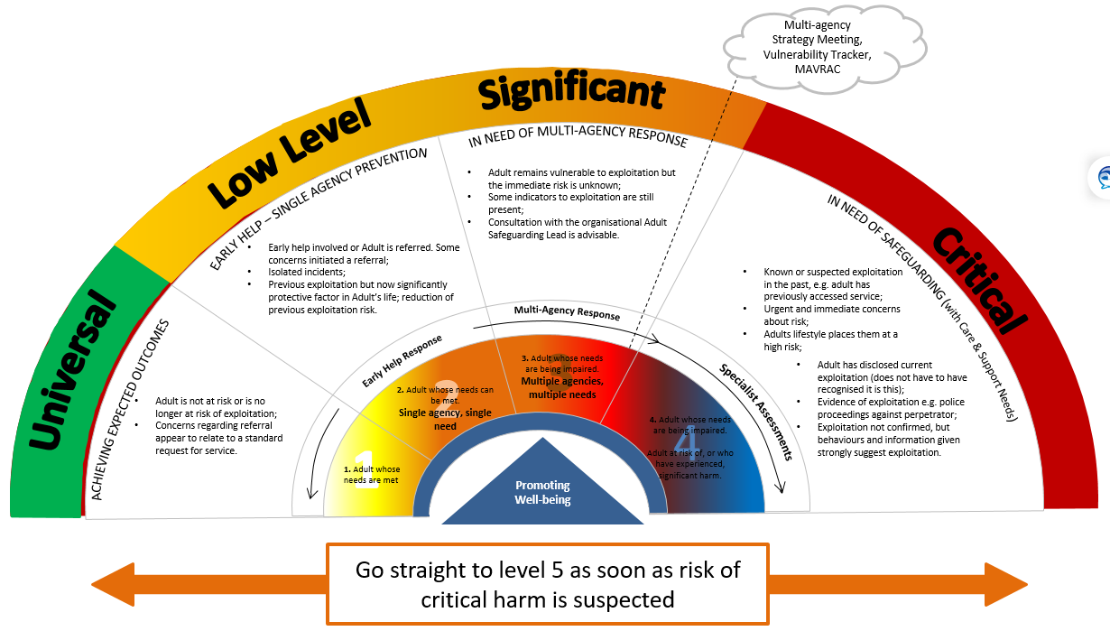
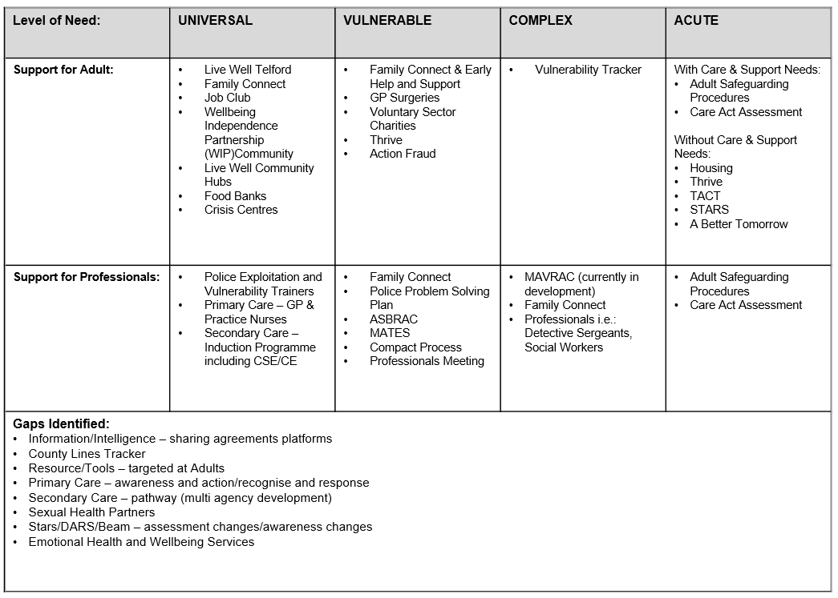

For further information please refer to the West Midlands Adult Safeguarding Policy & Procedures which can be found here: https://www.safeguardingwarwickshire.co.uk/safeguarding-adults/i-work-with-adults/west-midlands-regional-safeguarding-information-hub
For further information please refer to the West Midlands Adult Safeguarding Policy & Procedures which can be found here: https://www.safeguardingwarwickshire.co.uk/safeguarding-adults/i-work-with-adults/west-midlands-regional-safeguarding-information-hub

