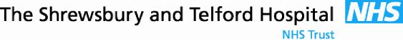

SaTH Standard Operating Procedure has been written in conjunction with West Mercia Police, Shropshire Social Care and Telford & Wrekin Social Care

Dangerous Dogs Act 1991 – change to this act came into force in May 2014.
All Dog owners are responsible for the behaviour or their dog around other people and other animals.
It is against the Law to let a dog be out of control in
- Public Place
- Private Place
- The owner’s home

When seeing a child who has been bitten you need information
Has the dog bitten anyone before?
Time / place it happened
What was the dog doing beforehand?
What was the child doing beforehand e.g. antagonising the dog?
Breed of Dog

7 Minute Brief

Dog Bites
January 2024
All Dog Bites are to be reported to Social Care and the Police.
Complete a MARF for social care and report via Report a crime | West Mercia Police to the Police


www.gov.uk/control-dog-public/overview

Dangerous Dog Act 1991

The Law applies to all Dogs
Adult supervision with the dog
Has the child accidentally injured the dog, trod on it’s tail?

How old is the dog?

Out of Control
A dog is considered to be ‘out of control’ if it
Injures someone.
Makes someone worried they could be injured.
Injures another animal.
The owner thinks they could be injured trying to stop their dog attacking another animal.

