Telford and Wrekin Safeguarding Partnership

Resolution and Escalation Policy

Resolution of professional disagreements for partners who work across both Adult and Children’s Safeguarding services



INDEX | CONTENTS | Page
1. | Introduction | 3
2. | Purpose of the Policy | 3
3. | The Role of Professionals and Partner Agencies | 4
4. | Situations where Disagreements may Arise | 5
APPENDICES
Appendix 1 | Resolution and Escalation Process | 7
Appendix 2 | Resolution and Escalation Pathway | 11
Appendix 3 | Resolution and Escalation Referral Form | 12
Appendix 4 | Agency Safeguarding Leads Contact Details | 14

- Introduction

Telford and Wrekin Safeguarding Partnership (TWSP) and all partner agencies are committed to open and transparent joint working to safeguard and promote the welfare of children and adults. Raising questions, challenging and escalating concerns where appropriate, quickly and clearly is seen as a positive approach to practice and continuing improvement in how we protect and meet the needs of children and adults in Telford and Wrekin.

This guidance has been developed to enable a means of resolving professional differences or issues in specific cases, where one agency feel that the actions, inaction or decisions of another agency do not adequately safeguard a child or adult, through open communication.

- Purpose of the Policy

2.1 Working together in the complex business of safeguarding children and adults, will inevitably create occasions where there are professional difference of opinion or concerns about practice decisions, actions or lack of actions to a referral, assessment or an enquiry which is considered to be unsafe. Disagreements can be healthy and foster creative ways of working with children, adults and families. However, these disagreements always require swift resolution.

2.2 A child or adult’s safety and wellbeing must be the paramount consideration at all times and professional difference must not detract from timely and clear decision-making. All professionals working with children, adults and families have a duty to act assertively and proactively to ensure the individual’s welfare is seen as a priority at all levels of professional activity.

2.3 It is the responsibility of all professionals to initiate a challenge to actions, inaction or the decision made of other agencies where they believe there is evidence to suggest that the child or adult’s health, development, well-being or their safety may be compromised.

2.4 Professionals involved with the disagreement must ensure that problems are resolved within the shortest timescale possible to protect the individual/s. Partner agencies should therefore exercise their judgement as to whether the timelines outlined in this protocol need to be adjusted to achieve a resolution more quickly including funding or clinical disputes across partner agencies.

2.5 This document outlines the process for resolving multi-agency disputes arising from actions, inaction or decisions that are believed not to be in the best interest of a child, adult and/or family, or which is likely to place an individual/family at increased risk of harm. Single agency disputes or complaints should be channeled through single agency internal processes of escalation and/or complaints procedure.

2.6 Single agency policies in relation to dispute resolution should also make reference to, and direct professionals to use the multi-agency escalation policy, where necessary.

3. The Role of Professional and Partner Agencies

Professionals should:

3.1.1 Be open and honest to create good working partnerships, and use clear communication between staff from different agencies.

3.1.2 Share information appropriately in line with national and local guidance and to work to plans agreed in all relevant forums, to safeguard children and adults in the local area.

3.1.3 Always keep in mind that the child, young person or adult’s safety, welfare and well-being is paramount. Professionals should avoid disputes which place children or adults at further risk by obscuring the focus on the individual which delays decision-making.

3.1.4 Be encouraged to seek resolution as soon as possible, at practice level (see Appendix 1). All agencies should adopt a proactive approach towards problem solving which enables professional disagreements to be resolved as close to front line practice as possible and relevant professionals included, i.e. Safeguarding and LAC.

3.1.5 Know which other agencies and individual staff members are involved with the child, young person, adult and their family.

3.1.6 Always base their actions on a robust assessment of the risk of harm to the child(ren) or adult and the impact of the given situation on the individuals wellbeing. The process sets out expected timescales within which matters should be escalated where an inter-agency disagreement has arisen, in some situations it may be necessary to act sooner to protect a child(ren) or adult.

3.1.7 Liaise with the safeguarding lead or designated child protection/children in care lead in their organisation at the earliest opportunity. Clarity is expected from all agencies in respect of designated roles and responsibilities (see Appendix 4).

3.1.8 Be aware of the escalation routes within their own agency, and know who to keep informed about the dispute.

3.1.9 Ensure that all stages of the process, conversations, actions and decisions are recorded (on the file) and shared with relevant personnel (including the worker who raised the initial concern). This must include written confirmation between the parties about an agreed outcome of the disagreement and how any outstanding issues will be pursued.

3.1.10 Highlight any gaps in policies, procedures and/or processes, to the attention of the Partnership Team who will inform the Independent Chair of the Telford and Wrekin Safeguarding Partnerships

3.1.11 Stay proactively involved with the dispute; safeguarding is everyone’s responsibility.

3.1.12 Use the TWSP Resolution and Escalation process set out in Appendix 1 and 2.

If a child or adult is thought to be at immediate risk of harm the designated safeguarding lead within the agency identifying the concern should be informed immediately. It is noted that not all agencies are required to do this, therefore if this is the case, the professional themselves should make contact with Family Connect on 01952 385385.

4. Situations where Disagreements may Arise

There may be occasions where one professional disagrees with the actions of another professional and therefore in such cases the TWSP Escalation Policy should be followed. Some examples include the following (although the list is not exhaustive):

- Where one professional disagrees with the action of another in relation to a particular course of action, such as closing involvement with a child, adult or family.

- Where one worker or partner agency considers that another worker or partner agency has not completed an agreed action for no understandable or acceptable reason.

- Where one partner agency considers that the threshold for action is inappropriate to support a child or adults needs and /or places an individual at further risk.

- A disagreement as to whether a particular partner agency needs to be involved in the safeguarding process.

- Where a member of staff or partner agency considers that the child’s safeguarding needs are better met by a Child Protection Plan and have requested that a Child Protection Conference be called and feel that this has been refused.

- Where a member of staff or a partner agency considers that the adult’s safeguarding needs are better met by a Care Act (2014) Assessment of their needs or adult social care intervention or a specialist health assessment or health intervention for example. The member of staff or partner agency have requested a referral with the adult’s consent (or in their best interests if they lack mental capacity to consent) and feel that this has been refused.

- Where a range of professionals have concerns about a partner agency’s response to safeguarding concerns relating to a specific child, adult or child in care out of area.

- There is disagreement over the sharing of information and/or provision of services.

- Where a partner agency has been asked to carry out a section 42 enquiry on behalf of the Local Authority but has declined to do so.

APPENDIX 1 – TWSP Resolution and Escalation Process
Professionals should attempt to resolve differences through discussion within 10 working days or a timescale that protects the child or adult from harm (whichever is shortest)
Stage No. | Parties involved | Process | Duration | Cumulative Duration
1 | Practitioners | Upon disagreement in relation to the safeguarding needs of a child or adult, in the first instance the practitioner from the other partner agency should raise the matter with the responsible practitioner verbally and in writing within 2 working days of the disagreement or receipt of a decision. | 2 days | 2 days
1 | Practitioners | The practitioner should provide clear evidence-based reasons for their disagreement. The receiving partner agency must read and review the particular case file. They must speak to the disputing practitioner and attempt to find a mutually agreeable way forward within 3 working days.  Where a resolution is reached, the responsible practitioner will advise the partner agency of the outcome in writing (i.e. email) within a further 2 working days.  WHEN ANY PROFESSIONAL CONSIDERS A CHILD OR ADULT IS AT IMMEDIATE RISK OF SIGNIFICANT HARM, THEN THE INDIVIDUAL MUST ENSURE THEIR CONCERNS ARE ESCALATED ON THE SAME WORKING DAY USING ESTABLISHED SAFEGUARDING PROCEDURES. | 5 days | 7 days

Stage No. | Parties involved | Process | Duration | Cumulative Duration
2 | Line/ Team Managers | If the receiving partner agency practitioner and the disputing practitioner are unable to resolve the disagreement following exploration of the facts, each practitioner should raise their concerns with their respective manager, who after consultation with their safeguarding leads should attempt to resolve the differences within 2 working days.  If agreement is reached, the receiving partner agency will write to the disputing partner agency confirming the outcome within a further 2 working days. | 4 days | 11 days
3 | Senior Managers/Designated Safeguarding Leads | If agreement cannot be reached following discussions between the line managers, the issue must be referred in writing, using the TWSP Resolution and Escalation Form (Appendix 3) within 24 hours to the relevant senior manager or other designated professional. The relevant managers should engage in dialogue within 2 working days to resolve the issue. | 3 days | 14 days
4 | Assistant Director/Director | Where a resolution is still not agreed after Stage 3, the service/senior manager will raise the disagreement within a further 2 working days with their partner agency or sector's TWSP representative.  Their TWSP representative (or a senior manager delegated by the TWSP rep) will then write to their equivalent in the partner agency that is the subject of the dispute and meet within a further 2 working days to achieve a final resolution  Exceptional Circumstances  TWSP expects that professional disputes will be resolved within the first 3 stages of the process set out above, however, it is recognised that there may be occasions when some issues will remain unresolved at the end of stage 3 above. Where this is the case, a referral should be made for the attention of the TWSP, who will mediate the activities through to a resolution and inform relevant professional bodies if appropriate, i.e. Care Quality Commission Home Concerns. | 4 days | 18 days
5 | TWSP Safeguarding Children or Adult Board (as appropriate) | In exceptional circumstances only, where the matter remains unresolved and the concerns of the complaining agency persist, the Director of this partners agency should write immediately and within no more than 2 working days, to the TWSP SAB or SCB, via the TWSP Partnership Team.  The TWSP SAB/SCB will seek written representation initially, and may request a meeting with those involved at all levels of service delivery to seek their views and solutions to the concerns raised. The TWSP SAB/SCB will make a final and binding decision on the most appropriate way to proceed and this will be communicated to all involved within 5 working days of the issue being brought to his/her attention.  Alternatively, the TWSP SAB/SCB will identify a Board member from an uninvolved agency to chair a meeting of the most senior managers with operational responsibility for the case. This meeting will review the issues at hand and provide a final opportunity for the involved agencies to ensure that there is a full understanding of the issues before the decision is finalised. The chair of this meeting will report back to the TWSP SAB/SCB.  If through the mechanism described, the SCB cannot resolve the issues at hand, then the matter will be escalated to the LSPs. The LSPs will identify an appropriate lead who will chair a meeting to consider the matter and reach a decision. The LSP will report back to the next LSP meeting. | 7 days | 25 days
6 | Debrief for practitioners involved with the dispute | It may be useful for individuals to debrief following some disputes in order to promote continuing good working relationships.
7 | End of the process | At the end of the process, once the Resolution and Escalation Referral Forms have been completed by the senior manager/DSL involved in seeking a resolution, a copy should be sent to the TWSP Partnership Team, who in consultation with the TWSP Adult Learning, Review and Training (ARLT) and Safeguarding Children Partnership (PD) Sub-groups will undertake a bi-annual review. A report will be presented to both Safeguarding Adults and Children Board’s on agency involvement numbers, trends and ongoing challenges.

APPENDIX 2 – TWSP Resolution and Escalation Pathway
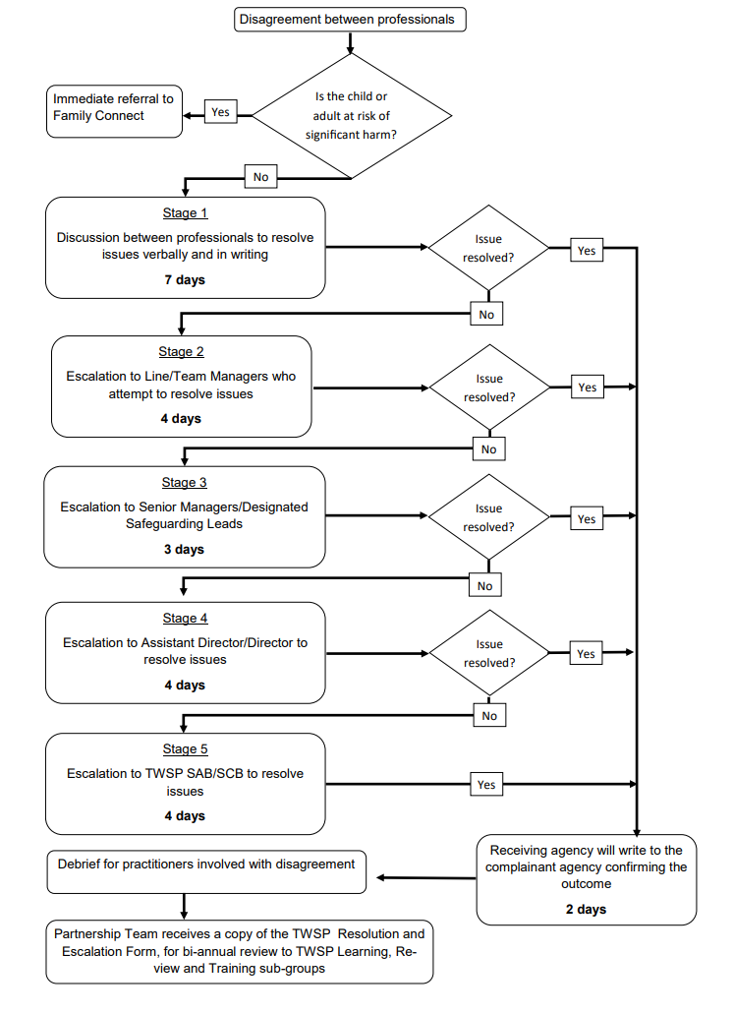
APPENDIX 3 – Resolution and Escalation Referral Form
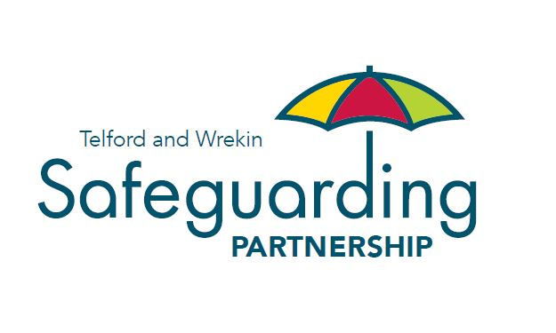
Telford & Wrekin Safeguarding Partnership

Resolution and Escalation Referral Form

FORMAL ESCALATION FORM (to be used from Stage 3 only and sent to the relevant senior manager or other designated professional)

Client Reference Number (if applicable): |  |  | Date:
Name of Individual:
Date of Birth: |  |  | NHS Number:
Agency/Team:
Named GP and Surgery:
Summary of Concerns, including the specific difference/s which has resulted in utilising the Escalation process:
(It is important that you provide information that details how you have made every effort to resolve this matter at a local level within Stages 1 & 2)

Requested Action:

Response:

Date: |  | Signature:
Resolution of Issues:

Date: |  | Signature:
Actions taken to resolve the professional disagreement:

Date: |  | Signature:
APPENDIX 4 – Agency Safeguarding Leads Contact Details
Agency | Role | Contact Details
CAFCASS | Service Manager | 07768 728467
Family Connect | Safeguarding Hub | 01952 385385
Midlands Partnership Foundation NHS Trust | Head of Strategic Safeguarding | 01785 895629
Shrewsbury and Telford NHS Trust | Lead Nurse for Safeguarding Children | 01952 641222  ext 4195
Shrewsbury and Telford NHS Trust | Head of Adult Safeguarding | 01743 261000 ext 3859
Shropshire Community Health Trust | Head of Safeguarding | 01952 580387
Telford & Wrekin Council | Director, Children's Safeguarding and Family Support | 01952 385723
Telford & Wrekin Council | Director Education and Skills | 01952 380800
Telford & Wrekin Council | Director Adult Social Care: Adult Social Care | 01952 383002
NHS Shropshire, Telford & Wrekin Integrated Care Board | Chief Nursing Officer  Designated Safeguarding Leads and Designated Nurse Looked After Children. | 01952 580417  01952 580300
The Probation Service | Head of Service | 01952 984464
West Mercia Police | Chief Inspector | 101
West Midlands Ambulance Service | Safeguarding Manager | wmas.safeguarding@wmas.nhs.uk
Wrekin Housing Trust | Neighbourhood Manager | 01952 217100
Youth Offending Team | Head of Service | 01952 385963

Partner agencies can be defined as any organisation who works with the Telford and Wrekin Safeguarding Partnership, and any of its partners.

