

Telford and Wrekin Safeguarding Partnership

Hoarding Policy & Procedure

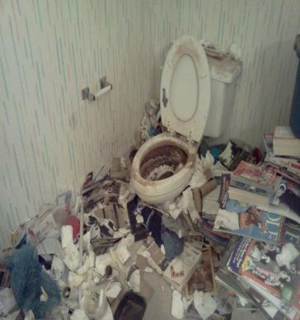
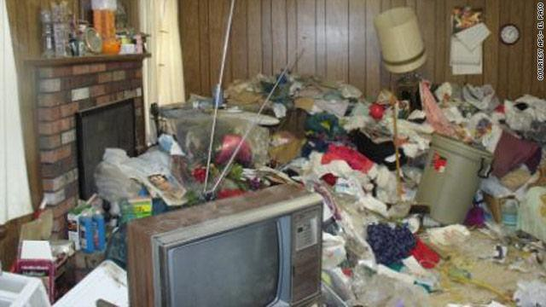
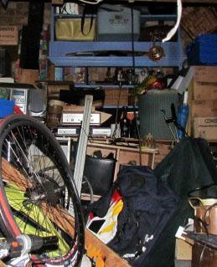
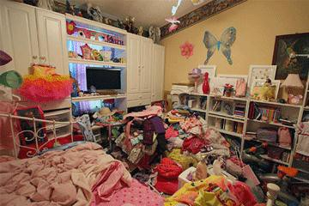
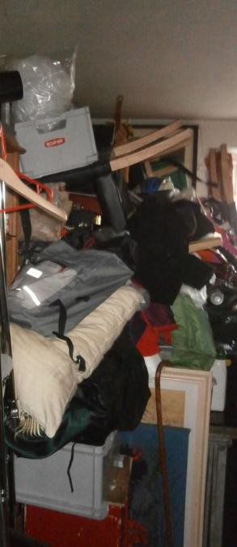



INDEX | CONTENTS | Page
0. | Introduction | 3
1. | Who does the Policy apply to? | 3
2. | Aims of Policy | 3
3. | Definition of Hoarding | 3
4. | Key Facts | 4
5. | Types of Hoarding | 5
6. | General Characteristics of Hoarding | 5
7. | Care Act 2014 | 6
8. | Undertaking assessments despite capacitated refusal | 7
9. | Mental Capacity | 7
10. | Executive functioning | 8
11. | Information Sharing | 9
12. | Fire Safety | 10
13. | Legal Powers | 11
14. | Safeguarding Children (Family Connect) | 13
15. | Safeguarding Adults | 13
16. | Engaging the person who hoards | 14
17. | Multi Agency Response | 15
18. | Multi-Agency Hoarding Conference Meeting | 15
19. | Ceasing involvement with an adult who is hoarding. | 16
20. | The Business Process | 17
APPENDICES
Appendix 1 | Detailed Business Process Flowchart | 19
Appendix 2 | TWSP Hoarding and Clutter Image Rating Assessment – Practitioners Guidance Notes | 20
Appendix 3 | TWSP Hoarding and Clutter Image Rating Assessment | 33
Appendix 4 | TWSP Multi-Agency Hoarding Conference Meeting Agenda Template | 39
Appendix 5 | Useful Contacts | 40
Appendix 6 | Useful Websites | 42

Special thanks to the London Borough of Merton for allowing us to use their Hoarding Protocol as the basis for this policy framework.
Introduction
This policy sets out a framework for collaborative multi-agency working using an outcome focused, person centered solution based model. The policy offers clear guidance to staff working with people who hoard.

Compulsive hoarding is highly complex and requires a collaborative and integrated approach. This policy aims to ensure there is meaningful, coordinated multi-agency partnership working with people who hoard in order to reduce duplication for both the agencies and individuals. The policy aims to facilitate positive and sustainable outcomes for individuals, by involving them in the process at all stages.

- Who does the Policy apply to?

This policy applies to all agencies who come into contact with people who are hoarding, and those who have agreed to support the framework.

There is an expectation that everyone engages fully in partnership working to achieve the best outcome for people who hoard while meeting the statutory requirements and duties of their individual agencies or Board.

- Aims of the Policy

The aims of this policy are to:

- Create a safer and healthier environment for the individual and others affected by the hoarding behavior, e.g. family, neighbours.

- Develop a multi-agency pathway which will maximise the use of existing services and resources and which may reduce the need for compulsory solutions.

- Ensure that when solutions are required, there is a process for planning solutions tailored to meet the needs of the individual following an assessment and utilizing a person centered approach. Solutions should include professional support and monitoring, property repairs and permanent or temporary re-housing.

- Develop creative ways of engaging individuals in the process.

- To establish best practice and improve knowledge of legislation that relates to hoarding behaviour.

- Definition of Hoarding

Hoarding is the excessive acquisition and an inability or unwillingness to discard large quantities of objects that cover the living areas of the home and cause significant distress or impairment (Frost & Hartl,1996). Pathological or compulsive hoarding is a specific type of behaviour characterised by:

- Acquiring and failing to throw out a large number of items that would appear to hold little or no value and would be considered rubbish by other people.

- Severe “cluttering” of the person's home so that it is no longer able to function as a viable living space.

- Significant distress or impairment of work or social life (Kelly 2010).

Hoarding Disorder used to be considered a form of obsessive compulsive disorder (OCD). However, hoarding is now considered a standalone mental disorder and is included in the 5th edition of the Diagnostic and Statistical Manual of Mental Disorders 2013 and ICD-11 (International Classification of Diseases).

Hoarding, can also be a symptom of other mental disorders. Hoarding Disorder is distinct from the act of collecting, and is also different from people whose property is generally cluttered or messy. It is not simply a lifestyle choice. The main difference between a person who hoards and a collector is that people who hoard have strong emotional attachments to their objects which are well in excess of their real value.

Hoarding does not favour a particular gender, age, ethnicity, socio-economic status, educational/occupational history or tenure type.

Anything can be hoarded, in various areas including the resident's property, garden or communal areas. Commonly hoarded items include but are not limited to:

- Clothes.
- Newspapers, magazines or books.
- Bills, receipts or letters.
- Food and food containers.
- Animals.
- Medical equipment.
- Collectibles such as toys, videos, DVDs, or CDs.
- Own feacal matter and urine.

- Key Facts

- It is estimated that between 2% and 5% of the population hoard.
- This equates to at least 1.2 million households across the UK.
- It is estimated that only 5% of hoarders come to the attention of statutory agencies.
- Hoarding cases can cost up anywhere from £1000 to £60000.
- 20-30% of OCD sufferers are hoarders (Chartered Institute of Environmental Health).
- Often, people who hoard can stop landlords from meeting their statutory duties – i.e. Gas safety checks and other certification required for Registered Social Landlords.

- Types of Hoarding

There are three types of hoarding:

- Inanimate objects
This is the most common. This could consist of one type of object or a collection of a mixture of objects such as old clothes, newspapers, food, containers or papers.

- Animal Hoarding
Animal hoarding is on the increase. This is the obsessive collecting of animals, often with an inability to provide minimal standards of care. The person who hoards is unable to recognise that the animals are or may be at risk because they feel they are saving them. In addition to an inability to care for the animals in the home, people who hoard animals are often unable to take care of themselves. As well, the homes of animal hoarders are often eventually destroyed by the accumulation of animal faeces and infestation by insects.

- Data Hoarding
This is a new phenomenon of hoarding. There is little research on this matter and it may not seem as significant as inanimate and animal hoarding, however people that do hoard data could still present with same issues that are symptomatic of hoarding. Data hoarding could present with the storage of data collection equipment such as computers, electronic storage devices or paper. A need to store copies of emails, and other information in an electronic format.

- General Characteristics of Hoarding

Paul Salkovski, professor of clinical psychology at the University of Bath made an interesting analysis of the problem, in that people who hoard fall into one of three categories.

“The first group, around 25% of the total, are people with what might be termed “obsessive compulsive hoarding”; their problem is harm avoidance, because they fear things could be contaminated and worry about contaminating others if they get rid of the,. The second group, who make up about half of all those affected, are deprivation hoarders: they have been through a period of massive deprivation (for example, war, displacement or another sort of loss) and they hoard because, having lost so much once, they feel a need to hold on to possessions in case catastrophe strikes again. The third group…are sentimental hoarders. They have been damaged by unpredictability and possibly even neglect during childhood: for them, possessions have become more reliable than people and they invest in them accordingly.”

Hoarding can be categorized as self-neglect, however not all hoarding is self-neglect.

- Fear and anxiety: compulsive hoarding may have started as a learnt behaviour or following a significant event such as bereavement. The person hoarding believes buying or saving things will relieve the anxiety and fear they feel. The hoarding effectively becomes their comfort blanket. Any attempt to discard hoarded items can induce feelings varying from mild anxiety to a full panic attack with sweats and palpitations.

- Long term behaviour pattern: possibly developed over many years, or decades, of “buy and drop”. Collecting and saving, with an inability to throw away items without experiencing fear and anxiety.

- Excessive attachment to possessions: people who hoard may hold an inappropriate emotional attachment to items.

- Indecisiveness: people who hoard struggle with the decision to discard items that are no longer necessary, including rubbish.

- Unrelenting standards: people who hoard will often find faults with others, require others to perform to excellence while struggling to organise themselves and complete daily living tasks.

- Socially isolated: people who hoard will typically alienate family and friends and may be embarrassed to have visitors. They may refuse home visits from professionals, in favour of office based appointments.

- Large number of pets: people who hoard may have a large number of animals that can be a source of complaints by neighbours. They may be a self-confessed “rescuer of strays”.

- Mentally competent: people who hoard are typically able to make decisions that are not related to the hoarding.

- Extreme clutter: hoarding behaviour may prevent several or all the rooms of a person's property from being used for its intended purpose.

- Churning: hoarding behaviour can involve moving items from one part of a person's property to another, without ever discarding anything.

- Self-Care: a person who hoards may appear unkempt and disheveled, due to lack of toileting or washing facilities in their home. However, some people who hoard will use public facilities, in order to maintain their personal hygiene and appearance.

- Poor insight: a person who hoards will typically see nothing wrong with their behaviour and the impact it has on them and others.

- Care Act 2014

The Care Act, 2014 builds on recent reviews and reforms, replacing numerous previous laws, to provide a coherent approach to adult social care in England. Local authorities (and their partners in health, housing, welfare and employment services) must now take steps to prevent, reduce or delay the need for care and support for all local people.
The Care Act introduced three new indicators of abuse and neglect to Adult Safeguarding. The most relevant to this hoarding guidance is self-neglect. The guidance states; this covers a wide range of behaviour neglecting to care for one’s personal hygiene, health or surroundings and includes behaviour such as hoarding. In practice, this means that when an adult at risk has care and support needs, their case may require a safeguarding enquiry.
Initial intervention from Adult Social Care would be to offer an individual an assessment of their care and support needs; this may avoid the need to enter formal Safeguarding procedures.
- Undertaking assessments despite capacitated refusal
As a matter of practice, it will always be difficult to carry out an assessment fully where an adult with mental capacity is refusing. Practitioners and managers should record fully all the steps that have been taken to undertake a needs assessment. This should include recording what steps have been taken to involve the adult and any carer, as required by section 9(5) of the Care Act, and assessing the outcomes that the adult wishes to achieve in day to day life and whether the provision of care and support would contribute to the achievement of those outcomes, as required by section 9(4) of the Care Act.
Where a practitioner has begun working with an adult and subsequently identifies that there may be self–neglect concerns they should initially speak with the adult where possible to ascertain their views. It would also be appropriate to engage with other professionals to share concerns and gather information. Acting in this way will assist with decision making and consider the least restrictive approach.
Gathering information would also identify any additional risk factors, e.g. risk to children or other adults, and ensure that where necessary appropriate referrals are made.
In light of the adult’s on-going refusal or capacitated choices, the result may either be that it has not been possible to undertake an assessment fully or the conclusion of the needs assessment is that the adult refuses to accept the provision of any care and support. However, case recording should always be able to demonstrate that all necessary steps have been taken to carry out a needs assessment that is reasonable and proportionate in all the circumstances.
As part of the assessment process, it should be demonstrated that appropriate information and advice has been made available to the adult, including information and advice on how to access care and support.

- Mental Capacity

The Mental Capacity Act (MCA) 2005 provides a statutory framework for people who lack capacity to make decisions for themselves. The Act has five statutory principles and these are the legal requirements of the Act:

- A person must be assumed to have capacity unless it is established that they lack capacity.
- A person must be given all practicable help before they are treated as not being able to make their own decisions.
- A person should not be treated as lacking capacity to make that decision, because they make what might be seen as an unwise decision.
- Any decision made on behalf of a person who lacks capacity must be done or made in their best interests.
- Before a decision is made for or on behalf of a person who lacks capacity, regard must be given to find a way that is the least restrictive on their basic rights and freedom of action.

When a person’s hoarding behaviour poses a serious risk to their health and safety, professional intervention will be required. With the exception of statutory requirements, any intervention or action proposed must be with the persons consent. In extreme cases of hoarding behaviour, the very nature of the environment should lead professionals to question whether the person has capacity to consent to the proposed action or intervention and trigger a capacity assessment.

The MCA Code of Practice states that one of the reasons why people may question a person's capacity to make a specific decision is "the person's behaviour or circumstances cause doubt as to whether they have capacity to make a decision” (4.35 MCA Code of Practice, P. 52). Extreme hoarding behaviour may therefore in the specific circumstances of the case, prompt an assessment of capacity.

- Executive Functioning

It has been recognised that there are complex situations in which concerns arise about executive dysfunction. This matter has been addressed specifically in the revised draft Code of Practice to the Mental Capacity Act. Whilst there is no publication date for the new Code it did recognise the “common area of difficulty……where a person with an acquired brain injury gives coherent answers to questions, but it is clear from their actions that they are unable to give effect to their decision. This is sometimes called an impairment in their executive function. If the person cannot understand (and/or use and weigh) the fact that there is a mismatch between what they say and what they do when required to act, it can be said that they lack capacity to make the decision in question. However, this conclusion can only properly be reached when there is clear evidence of repeated mismatch between what the person says and what they do. This means that in practice it is unlikely to be possible to conclude that the person lacks capacity as a result of their impairment on the basis of one single assessment.”

There are further explorations of the impact of what is also referred to as “Dysexecutive Syndrome” from case law discussions. Frequently the focus is upon people with acquired brain injuries were there is “evidence of repeated mismatch/divorce between saying and doing.” This has been referred to as the “the frontal lobe paradox,” where those with frontal lobe damage can perform well in interview and test settings, despite marked impairments in everyday life.

It is therefore critical that when assessing capacity practitioners take account of the potential existence of an impairment of the mind or the brain that has an impact on executive functioning despite the existence of verbal skills. Equally practitioners “should also guard against” believing a gap between being able to seemingly verbalise an issue of concern that needs an action and then not taking the actions does not necessarily mean the person lacks capacity about that decision. Practitioners should remember that section1(4) of the Mental Capacity Act states: P is not to be treated as unable to make a decision merely because he makes an unwise decision.

The Social Care Institute of Excellence (SCIE) has provided valuable resources to assist practitioners when dealing with these issues.

SCIE have stated that there is no single definition of executive function, but it involves goal-oriented behaviour, including: planning, organisation, fluency, inhibition, mental flexibility, and abstract reasoning. Disorders most likely to be prevalent when undertaking assessments which give raise to complex interpretations around capacity and executive functioning can include conditions that originally had a sudden onset with scope for improvement (even after some time) e.g., stroke, blunt external force (road traffic accident) especially involving injury to the frontal lobe and conditions with slow progressive deterioration e.g., frontotemporal dementia. It is also stressed there is a need to consider contextual information; information about the type of impairment of brain; the history about change in the person’s goal directed behaviour; collateral sources of information from people with longitudinal knowledge of the person and information about how the person makes decisions outside of structured environments.
An urgent or emergency application to the Court of Protection
You can apply to the Court of Protection to get an urgent or emergency court order in certain circumstances, for example when someone’s life or welfare is at risk and a decision has to be made without delay. If the court agrees, you’ll be able to make the necessary decision on behalf of the person who lacks mental capacity.
You won’t get a court order unless the court decides it’s a serious matter with an unavoidable time limit.
An urgent interim order
You can get an urgent interim order if you’re applying to become a deputy but your application hasn’t been approved yet.

- Information Sharing

Under the General Data Protection Regulations, we all have the responsibility to ensure that personal information is processed lawfully and fairly. People we work with have a right to view any information held about them. Practitioners should consider this when they are recording information about that person.

For the purpose of this protocol we will refer to the Telford and Wrekin Safeguarding Partnership (TWSP) Information sharing protocol. Information will be shared within and between organisations and departments in line with the principles set out below:

- Adults have a right to independence, choice and self-determination. This right extends to them being able to have control over information about themselves and to determine what information is shared. Consent should always be sought from the person; it is good practice to do so.

- The person's wishes should always be considered, however, protecting adults with care and support needs establishes a general principle that an incident of suspected or actual abuse can be reported more widely and that in so doing, some information may need to be shared among those involved.

- Information given to an individual member of staff belongs to the organisation and not to the individual employee. An individual employee cannot give a personal assurance of confidentiality to an adult with care and support needs.

- An organisation should obtain the adult with care and support needs written consent to share information and should routinely explain what information may be shared with other people or organisations.

- Difficulties in working within the principles of maintaining the confidentiality of an adult should not lead to a failure to take action to protect the adult from abuse or harm.

- Confidentiality must not be confused with secrecy, that is, the need to protect the management interests of an organisation must not override the need to protect the adult.

- Staff reporting concerns at work ("whistleblowing") is entitled to protection under the Public Interest Disclosure Act 1998.

The decisions about what information is shared and with whom will be taken on a case by case basis. Whether information is shared with or without the adult with care and support needs consent, the information shared should be:

- Necessary for the purpose for which it is being shared.
- Shared only with those who have a need for it.
- Be accurate and up to date.
- Be shared in a timely fashion.
- Be shared accurately.
- Be shared securely.

- Fire Safety

Hoarding poses a significant risk to both the people living in the hoarded property and those living nearby. Where a hoarded property is identified regardless of the risk rating, those individuals need to be advised of the increased risk and identify a safe exit route.

Appropriate professional fire safety advice must be sought.

Sharing information with appropriate emergency services by alerting them to hoarded properties will allow them to respond appropriately.

Once properties are cleared the information must be updated.

A Safe and Wellbeing visit undertaken by the Fire & Rescue Service may be appropriate.

- Legal Powers

Public Health Act 1936

Section 83: Cleansing of filthy or verminous premises

Where any premises, tent, van, shed, ship or boat is either;

- filthy or unwholesome so as to be prejudicial to health; or
- verminous (relating to rats, mice other pests including insects, their eggs and
larvae).

LA serves notice requiring clearance of materials and objects that are filthy, cleansing of surfaces, carpets, etc. within 24 hours or more. If not complied with, Environmental Health (EH) can carry out works in default and charge. No appeal against notice but an appeal can be made against the cost and reasonableness of the works on the notice.

Section 84: Cleansing or destruction of filthy or verminous articles

Any article that is so filthy as to need cleansing or destruction to prevent injury to persons in the premises, or is verminous, the LA can serve notice and remove, cleanse, purify, disinfect or destroy any such article at their expense.

  - Housing Act 2004

If a complaint is received regarding the condition of a premises within its area the Local Housing Authority (LHA) is authorised to carry out inspections of any residential premises to identify hazards that are likely cause harm and to take the necessary enforcement action; to reduce the risk of harm.
Within the Housing Act 2004 Parts 1 – 4 and Parts 6 - 7 the Housing Health and Safety Rating System (HHSRS) is used to identify any hazards present within the premises. There is a duty by the LHA to take action on all identified Category One hazards and the LHA can decide whether or not to take action with regard to identified Category Two hazards. Taking action includes serving legal notices upon the owners/ persons responsible and can include Improvement Notices, Prohibition Orders etc. The LHA can also prosecute for non-compliance of any notice served, however, an appeal against any notice must be submitted to the Residential Property Tribunal (First tier Tribunal) for consideration within 21 days of service.

  - The Town and Country Planning Act 1990.
Section 215 (s215) of the Town & Country Planning Act 1990 (the Act) provides a local planning authority (LPA) with the power, in certain circumstances, to take steps requiring land to be cleaned up when its condition adversely affects the amenity of the area. If it appears that the amenity or part of their area is being adversely affected by the condition of neighbouring land and buildings, they may serve a notice on the owner requiring that the situation be remedied. These notices set out the steps that need to be taken, and the time within which they must be carried out. LPAs also have powers under s219 to undertake the clean-up works themselves and to recover the costs from the landowner.
The use of s215 by LPAs is discretionary and it is therefore up to the LPA to decide whether a notice under these provisions would be appropriate in a particular case, taking into account all the local circumstances. LPAs will need to consider, for example, the condition of the site, the impact on the surrounding area and the scope of their powers. In some circumstances s215 notices may be used in conjunction with other powers, for example, repair notices in respect of listed buildings or dangerous structure notices.
The most important message that LPAs should be aware of is that s215 action can be taken against land and buildings

- Prevention of Damage by Pests Act 1949

Section 4: Power of LA to require action to prevent or treat Rats and Mice

Notice may be served on owner or occupier of land/premises where rats and/or mice are or may be present due to the conditions at the time. The notice may be served on the owner or occupier and provide a reasonable period of time to carry out reasonable works to treat for rats and/or mice, remove materials that may feed or harbour them and carry out structural works. The LA may carry out works in default and charge for these.

Environmental Protection Act 1990

Section 80: Dealing with Statutory Nuisances (SNs)

SNs are defined in section 79 of the Act and include any act or omission at premises that prevents the normal activities and use of another premises, including the following:

Section 79 (1)

- any premises in such a state as to be prejudicial to health or a
nuisance;
- fumes or gases emitted from [private dwellings] premises so as to be
prejudicial to health or a nuisance;
- any accumulation or deposit which is prejudicial to health or a nuisance;
- any animal kept in such a place or manner as to be prejudicial to health
or a nuisance.

The LA serves an Abatement Notice made under section 80 to abate the nuisance if it exists at the time or to prevent its occurrence or recurrence.

- Hoarding of Animals

Evidence of animal hoarding at any level should be reported to the RSPCA.
https://www.rspca.org.uk/local/shropshire-branch/

- Safeguarding Children (Family Connect)

Safeguarding Children refers to protecting children from maltreatment, preventing the impairment of their health or development and ensuring that they are growing up in circumstances consistent with the provision of safe and effective care. Growing up in a hoarded property can put a child at risk by affecting their development and in some cases, leading to the neglect of a child, which is a safeguarding issue.

Where a child is residing in a property with a parent/carer who hoards, the interests of the child are paramount and where there are concerns that the child is at risk of significant harm the child must be referred to Family Connect.

Please refer to the following links for guidance: www.telfordsafeguardingpartnership.org.uk

The needs of the child at risk must come first and any actions we take will reflect this.

- Safeguarding Adults

This policy and procedure accepts the guidance as supplied in the West Midlands Regional Adult Safeguarding Information Hub

Statutory adult safeguarding procedures will apply where:

the adult has care and support needs as defined by the Care Act, and is experiencing or at risk of self –neglect (through hoarding behaviour), and is unable to protect themselves from self- neglect due to their refusal to engage with support.

An "adult with care and support needs" may also be living with the person who hoards in the property. There may be concern about the adult that they may be at risk of harm due to the living circumstances. If in doubt, discuss the issue with your line manager, the Adult Safeguarding Team or Family Connect.

When Information is evidenced, by completion of the TWSP Hoarding and Clutter Image Rating Assessment and if the person who hoards, is at criteria level 6 professionals must forward the assessment to Family Connect in order to raise a safeguarding alert under Section 42 of the Care Act. Professionals may also find it useful to refer to the Telford & Wrekin Safeguarding Partnership Threshold of Needs Matrix in order to support their professional decision making.

Reasons to raise an alert:

- Support is needed from the safeguarding team to promote effective multiagency working and use their expertise.

- The risks to the individual or others are deemed to be high (death or serious harm to the person and/or others).

There are Mental Health Powers that may also apply, to safeguard the person who hoards.

A person suffering from a mental disorder of a degree or nature may be detained under the Mental Health Act 1983 if there is a risk to both themselves and/or others; and they require a period of assessment and/or treatment in hospital.

Section 135 (1) Warrant to search for and remove persons
135.—(1) If it appears to a justice of the peace, on information on oath laid by an [approved mental health professional],^{[1]} that there is reasonable cause to suspect that a person believed to be suffering from mental disorder—
(a) has been, or is being, ill-treated, neglected or kept otherwise than under proper control, in any place within the jurisdiction of the justice, or
(b) being unable to care for himself, is living alone in any such place,
the justice may issue a warrant authorising any constable [...]^{[2]} to enter, if need be by force, any premises specified in the warrant in which that person is believed to be, and, if thought fit, to remove him to a place of safety with a view to the making of an application in respect of him under Part II of this Act, or of other arrangements for his treatment or care.
The link below details how to contact Telford & Wrekin Council to raise an Enquiry/Alert:
www.telfordsafeguardingpartnership.org.uk

- Engaging the Person who Hoards

Regardless of what process, organisations or pathway is used to work with a person who is hoarding, the starting point will always be engaging with the individual. Positive outcomes can be achieved through operational approaches informed by an understanding of the unique experience of each individual balanced with strategic and management input.

In engaging with the person consider:

- Whether they have the necessary information in a format they can understand.

- Whether they understand options and consequences of their choices.

- Listening to their reasons for mistrust, disengagement, refusal and their choices.

- Whether there is the time to have conversations over a period and building up of a relationship. Time must be given to a professional to build a relationship with the individual and assess the full condition of the property.

- Who can support you to engage with the person who hoards (whether family, advocate, other professional).

- Always involving attorneys, receivers, or representatives if the person who hoards has one. There may be a need to arrange a convenient appointment for the representative to be available.

- Determining a plan for agreed actions/outcome for the person who has fluctuating capacity is in place during a time when they had capacity for that decision.

- The person who hoards to attend meetings where possible.

The family member or carer of the individual should be engaged where the person who hoards has provided consent. This will include being part of planning, decision-making and whether they are willing and able to provide support. There are duties under the Care Act for carers and in relation to carers assessments.

The importance of taking time to build rapport with the individual is recognized as a key driver in building relationships which help positive changes take place. Before ceasing involvement with the adult due to lack of engagement consider more flexible or creative ways of working to ensure every opportunity it given to allow the individual to engage at a speed and in a manner in which they are comfortable.

- Multi-Agency Response

It is recognised that hoarding is a complex condition and that a variety of agencies will come into contact with the same person. It is also recognised that not all people will receive support from statutory services such as the Community Mental Health Team, Environmental Health, Police, Fire Service, NHS District Nurses or Early Help & Support.

Any professional working with people who may have or appear to a have a hoarding condition should ensure they complete the TWSP Hoarding and Clutter Image Rating Assessment to decide what steps to take.

- Multi Agency Hoarding Conference Meeting

Multi Agency Hoarding Conference Meetings are a process to discuss and review the assessment. If necessary, a discussion can also be held at this meeting to decide if the person has capacity to make specific decisions about being safe or managing their possessions. The meeting can also provide a framework for professionals to formulate an action plan identifying appropriate agency responsibility for actions, review and re-evaluation of the action plan.

A Multi-Agency Hoarding Conference Meeting should take place in the following circumstances:

- The person who hoards has full capacity to make unwise decisions and choices about their life but professionals have concern about the level of risk of hoarding and the risk it poses to them and others.

- The person who hoards is not engaging with services to reduce the risk and has been signposted to partner agencies (based on need) to ensure partner agencies have the opportunity to intervene and provide support in a timely manner but the person who hoards continues to make an unwise decision of their own free will not to engage with the support offered.

- There are concerns that the person lacks capacity, and is not engaging with support

The process may be applied when there are concerns from partner agencies and a multi-agency decision may benefit the outcome for the person who hoards.

- Ceasing involvement with an adult who is hoarding.

Before any professional considers ceasing involvement with someone who is self-neglecting due to hoarding items where professionals have not been able to engage with them, or risks remain a number of points may require consideration:
- Has capacity been addressed? Have you established whether the person has capacity to make decisions about their own wellbeing, and whether or not they are able or willing to care for themselves? In hoarding situations, the court gave guidance on the information that is relevant to decisions about items and belongs with the following information seen as relevant (see AC and GC (Capacity: Hoarding and Best Interests) [2022] EWCOP 39):
  - Volume of belongings and impact on use of room
  - Safe access and use
  - Creation of hazards
  - Safety of building
  - Removal/disposal of hazardous levels of belongings
- A person may say they understand the impact of their behaviour, but, can they actually carry out the actions they say they will (see section 10. Executive Functioning)
- Do they really understand the likely consequences of their behaviour or continuing to live as they are?
- Has a Care Act assessment been carried out (including under Section 11 if the adult has refused the assessment)?
- Have you considered carrying out a risk assessment or actually carried one out before ceasing involvement where the person is neglecting themselves or not engaging?
- Have you thought about the persons 'vital interests’ – is there an immediate risk of death or major harm?
- Are you assured that no one else is at risk, for example from fire? Where appropriate have you made a referral to the fire service?
- If others are at risk from the person's behaviour in relation to hoarding items, is it safe to cease involvement?
- Have other agencies have been informed and involved as necessary if you are ceasing involvement? Prior to ceasing involvement have you called a Multi-Disciplinary meeting and discussed this with other agencies who are involved or who could be involved? Is this recorded?
- Don’t forget to record mental capacity and risk assessments.
- Have you considered scheduling a review or follow up by your organisation or a partner agency at a later date?
- Are you assured that your organisation has fulfilled their legal duties to the adult and others at risk?
- Have enforced actions such as legal interventions been considered in serious circumstances?

It is important to be politely persistent rather than ceasing contact if there are times when engaging the adult is more difficult for them.
Reference: Norfolk Safeguarding Adults Board (2020) Safely ceasing involvement. https://www.norfolksafeguardingadultsboard.info/document/344/NSAB-Safely-Ceasing-Involvement-v2-061120.pdf

- The Business Process

For a detailed flowchart of the process, please refer to Appendix 1.

- Any professional working with a person who hoards can complete the TWSP Hoarding and Clutter Image Rating Assessment. (Appendix 3) To assist the professional, with completing the assessment, TWSP Hoarding and Clutter Image Rating Assessment Practitioner Guidance Notes are available, to provide useful hints and tips on what to include within the assessment. (Appendix 2)

- Following completion of the assessment, if the person who hoards is assessed as being at Clutter Image rating level 6 or above, then the TWSP Hoarding and Clutter Image Rating Assessment should be sent via secure email to Family Connect familyconnect@telford.gov.uk, within 24 hours of completion. The Adult Safeguarding Team will co-ordinate and chair a multi-agency hoarding conference meeting

- If a person is at criteria level 3- 5 and you as the professional have safeguarding concerns about the person, children or other adults with care and support needs within the property, then the TWSP Hoarding & Clutter Image Rating Assessment must be sent to Family Connect familyconnect@telford.gov.uk, within 24 hours of completion. The Adult Safeguarding Team will co-ordinate and chair a multi-agency hoarding conference meeting.

The Key partners to invite to multi-agency hoarding conference meetings are:
- Telford & Wrekin Council Environmental Health
- Shropshire Fire and Rescue Service
- Telford & Wrekin Council Adult Safeguarding Team.

Additional invites may need to be extended to any of the following (this will be case specific):
- Police
- Midlands Partnership NHS Foundation Trust
- GP
- Wrekin Housing Trust
- Any other relevant person

To assist with the meeting planning there is a Multi-Agency Hoarding Conference Meeting Template (Appendix 4), to ensure that each Multi-Agency Hoarding Conference Meeting follows the same format.

During the meeting the role and responsibilities of respective agencies will be agreed including which agency will take the lead including coordinating and chairing further meetings.

- If a person, is at criteria level 2, and it is felt that the individual would benefit from further support, they will be signposted/referred to appropriate agencies (Appendix 5 and 6).

- If the Multi-Agency team is unable to make progress in terms of supporting the person or the person refuses to engage with support the case should be escalated to the appropriate Service Delivery Manager or equivalent.

APPENDIX 1 – Detailed Business Process Flowchart
Adult Safeguarding Team will coordinate and chair multi-agency hoarding conference meeting
Information and Advice, Websites or Peer Support Groups
Concern about Hoarding Criteria Level 3 or above, or safeguarding concerns
Criteria Level 2
TWSP Hoarding and Clutter Image Rating Assessment (THCIRA) completed

Emergency Case to Public Protection for immediate response, site clearance or property repairs
Within 24 hours
Family Connect/ Safeguarding MASH

APPENDIX 2 – TWSP Hoarding and Clutter Image Rating Assessment – Practitioners Guidance Notes

Telford and Wrekin Safeguarding Partnership
Hoarding and Clutter Image Rating Assessment - Practitioners Guidance Notes
The following guidance notes are designed to help you complete the Telford and Wrekin Safeguarding Partnership Hoarding and Clutter Image Rating Assessment.

Once you have completed the assessment, there is a detailed business process to follow included within the Telford and Wrekin Safeguarding Partnership Hoarding Policy & Procedure which will advise of the next steps.

Contents

- The Assessment

- General Question Guidance
- Practitioner Observation Section
- Questions for Practitioners
- Guidance for completing the Clutter Image Rating Tool

- The Assessment

- General Question Guidance

- Consent to Share information with Social Care, NHS and other partners?

If consent is obtained this must be recorded. If consent is not obtained, then a reason must be recorded.

- Any Concerns about Capacity?

You may wish to consider whether the person has Capacity at this point, is aware of the questions you are raising. This may indicate they do not have capacity, therefore contact should be made with Adult Social Care to check whether the person has already had a Mental Capacity Assessment recently.

Please also refer to the section on Mental Capacity within the Telford and Wrekin Safeguarding Partnership Hoarding Policy & Procedure, for further information on the Mental Capacity Act 2005.

- What are the users views?

Use this guide as a baseline to describe the individual’s attitude towards their hoarding.

Good or fair awareness:

The customer recognises that hoarding-related beliefs and behaviours (relating to difficulty discarding items, clutter or excessive acquisition) are problematic. The customer recognises these behaviours in themselves.

Poor awareness

The customer is mostly convinced that hoarding-related beliefs and behaviours (relating to difficulty discarding items, clutter or excessive acquisition) are not problematic despite evidence to the contrary. The customer might recognise a storage problem but has little self-recognition or acceptance of their own hoarding behaviour.

No awareness

The customer is convinced that hoarding-related beliefs and behaviours (relating to difficulty discarding items, clutter or excessive acquisition) are not problematic despite evidence to the contrary. The customer is completely excepting of their living environment despite it being hoarded and possibly a risk to health.

Detached with assigned blame

The customer has been away from their property for an extended period. The customer has formed a detachment from the hoarded property and is now convinced a 3rd party is to blame for the condition of the property. For example a burglary has taken place, squatters or other household members.

- Practitioner Observations Section

Use this guide as a baseline to describe the hoarding issues present at the individuals property.

1. Property structure, services & garden area | - Assess the access to all entrances and exits for the property. (Note impact on any communal entrances & exits). Include access to roof space.  - Does the property have a smoke alarm?  - Visual Assessment of the condition of the services within the property e.g. plumbing, electrics, gas, air conditioning, heating, this will help inform your next course of action.  - Are the services connected?  - Assess the garden size, access and condition.
2. Household Functions | - Assess the current functionality of the rooms and the safety for their proposed use. E.g. can the kitchen be safely used for cooking or does the level of clutter within the room prevent it.  - Select the appropriate rating on the clutter scale.  - Please estimate the % of floor space covered by clutter  - Please estimate the height of the clutter in each room
3. Health and Safety | - Assess the level of sanitation in the property.  - Are the floors clean?  - Are the work surfaces clean?  - Are you aware of any odours in the property?  - Is there rotting food?  - Does the resident use candles?  - Did you witness a higher than expected number of flies?  - Are household members struggling with personal care?  - Is there random or chaotic writing on the walls on the property?  - Are there unreasonable amounts of medication collected? Prescribed or over the counter?  - Is the resident aware of any fire risk associated to the clutter in the property?
4. Children & Family members | - Does the household contain young people or children?
5. Animals and Pests | - Are the any pets at the property?  - Are the pets well cared for; are you concerned about their health?  - Is there evidence of any infestation? e.g. bed bugs, rats, mice, etc.  - Are animals being hoarded at the property?  - Are outside areas seen by the resident as a wildlife area?
6. Personal Protective Equipment (PPE) | - Following your assessment do you recommend the use of Personal Protective Equipment (PPE) at future visits? Please detail also taking into account how the occupant may view this.  - Following your assessment do you recommend the resident is visited in pairs? Please detail.

c. Questions for Practitioners

Listed below are examples of questions to ask where you are concerned about an individual’s safety in their own home.

The information gained from these questions will help inform the completion of the Telford and Wrekin Safeguarding Partnership Hoarding and Clutter Image Rating Assessment and provide the information needed to alert other agencies, if necessary. Most customers with a hoarding problem will be embarrassed about their surroundings so adapt the question to suit your customers.

- How do you get in and out of your property?
- Do you feel safe living here?
- Have you ever had an accident, slipped, tripped up or fallen? How did it happen?
- How have you made your home safer to prevent this (above) from happening again?
- How do you move safely around your home (where the floor is uneven or covered, or there are exposed wires, damp, rot, or other hazards)?
- Has a fire ever started by accident?
- How do you get hot water, lighting, heating in here? Do these services work properly? Have they ever been tested?
- Do you ever use candles or an open flame to heat and light here or cook with camping gas?
- How do you manage to keep yourself warm, especially in winter?
- When did you last go out in your garden? Do you feel safe to go out there?
- Are you worried about other people getting in to your garden to try and break-in? Has this ever happened?
- Are you worried about mice, rats or foxes, or other pests? Do you leave food out for them?
- Have you ever seen mice or rats in your home? Have they eaten any of your food or got upstairs and be nesting anywhere?
- Can you prepare food, cook and wash up in your kitchen?
- Do you use your fridge? Can I have look in it? How do you keep things cold in the hot weather?
- How do you keep yourself clean? Can I see your bathroom?
- Are you able to use your bathroom and use the toilet ok? Do you have a bath or shower?
- Can you show me where you sleep and let me see your upstairs rooms? Are the stairs safe to walk up? (If there are any)
- What do you do with your dirty washing?
- Where do you sleep? Are you able to change your bed linen regularly? When did you last change them?
- How do you keep yourself warm at night? Have you got extra coverings to put on your bed if you are cold?
- Are there any broken windows in your home? Any repairs that need to be done?
d. Guidance for completing the Clutter Image Rating Tool

Level 1  Clutter image rating  1 - 3 | Household environment is considered standard.  No specialised assistance is needed.
1. Property structure, services & garden area | - All entrances and exits, stairways, roof space and windows accessible.  - Smoke alarms fitted and functional or referrals made to fire brigade to visit and install.  - All services functional and maintained in good working order.  - Garden is accessible, tidy and maintained
2. Household Functions | - No excessive clutter, all rooms can be safely used for their intended purpose.  - All rooms are rated 0-3 on the Clutter Rating Scale  - No additional unused household appliances appear in unusual locations around the property  - Property is maintained within terms of any lease or tenancy agreements where appropriate.  - Property is not at risk of action by Environmental Health.
3. Health and Safety | - Property is clean with no odours, (pet or other)  - No rotting food  - No concerning use of candles  - No concern over flies  - Residents managing personal care  - No writing on the walls  - Quantities of medication are within appropriate limits, in date and stored appropriately.
4. Children & Family members | - No Concerns for household members
5. Animals and Pests | - Any pets at the property are well cared for  - No pests or infestations at the property
- Personal Protective Equipment (PPE) | - No PPE required  - No visit in pairs required.

Level 1 | Actions
Referring Agency | - Discuss concerns with resident  - Raise a request to the Fire Brigade to provide fire safety advice  - Refer for support assessment if appropriate.  - Refer to GP if appropriate
Environmental Health | - No Action
Social Landlords | - Provide details on debt advice if appropriate to circumstances  - Refer to GP if appropriate  - Refer for support assessment if appropriate.  - Provide details of support streams open to the resident via charities and self-help groups.  - Provide details on debt advice if appropriate to circumstances  - Ensure residents are maintaining all tenancy conditions
Practitioners | - Complete Hoarding Assessment and Clutter Image Rating Tool  - Make appropriate referrals for support  - Provide details of support streams open to the resident via charities and self-help groups.  - Refer to social landlord if the customer is their tenant or leaseholder
Emergency Services | - Ensure information is shared with statutory agencies & feedback is provided to referring agency on completion of home visits.
Animal Welfare | - No action unless advice requested
Family Connect | - No action unless other concerns of abuse are noted.

Level 2  Clutter Image Rating  4 – 5 | Household environment requires professional assistance to resolve the clutter and the maintenance issues in the property.
1. Property structure, services & garden area | - Only major exit is blocked  - Only one of the services is not fully functional  - Concern that services are not well maintained  - Smoke alarms are not installed or not functioning  - Garden is not accessible due to clutter, or is not maintained  - Evidence of indoor items stored outside  - Evidence of light structural damage including damp  - Interior doors missing or blocked open
2. Household Functions | - Clutter is causing congestion in the living spaces and is impacting on the use of the rooms for their intended purpose.  - Clutter is causing congestion between the rooms and entrances.  - Room(s) score between 4-5 on the clutter scale.  - Inconsistent levels of housekeeping throughout the property  - Some household appliances are not functioning properly and there may be additional units in unusual places.  - Property is not maintained within terms of lease or tenancy agreement where applicable.  - Evidence of outdoor items being stored inside
3. Health and Safety | - Kitchen and bathroom are not kept clean  - Offensive odour in the property  - Resident is not maintaining safe cooking environment  - Some concern with the quantity of medication, or its storage or expiry dates.  - No rotting food  - No concerning use of candles  - Resident trying to manage personal care but struggling  - No writing on the walls
4. Children & Family members | - Please note all additional concerns for householders  - Properties with children or vulnerable residents with additional support needs may trigger a Safeguarding referral under a different risk.
5. Animals and Pests | - Pets at the property are not well cared for  - Resident is not unable to control the animals  - Animal's living area is not maintained and smells  - Animals appear to be under nourished or over fed  - Sound of mice heard at the property.  - Spider webs in house  - Light insect infestation (bed bugs, lice, fleas, cockroaches, ants, etc.)
6. Personal Protective Equipment (PPE) | - Latex Gloves, boots or needle stick safe shoes, face mask, hand sanitizer, insect repellent.  - PPE required.
Level 2 | Actions  In addition to actions listed below these cases need to be monitored regularly in the future due to RISK OF ESCALATION or REOCURRENCE
Referring Agency | - Refer to landlord and Environmental Health, if resident is a tenant  - Refer to Environmental Health is resident is a freeholder  - Raise an request to the Fire Brigade to provide fire prevention advice  - Provide details of garden services  - Refer for support assessment  - Referral to GP  - Referral to debt advice if appropriate  - Refer to Animal welfare if there are animals at the property.  - Ensure information sharing with all agencies involved to ensure a collaborative approach and a sustainable resolution.
Environmental Health | - Refer to the Public Protection Team on 01952 381818 with details of customer, landlord (if relevant) referrer’s details and overview of problems  - At time of inspection, Environmental Health Officer decides on appropriate course of action  - Consider serving notices under Environmental Protection Act 1990, Prevention of Damage By Pests Act 1949 or Housing Act 2004 Consider Works in Default if notices not complied by occupier
Social Landlord | - Visit resident to inspect the property & assess support needs  - Ensure residents are maintaining all tenancy conditions.  - Enforce tenancy conditions relating to residents responsibilities.  - Ensure information sharing with all agencies involved to ensure a collaborative approach and a sustainable resolution.
Practitioners | - Complete Hoarding Assessment and Clutter Image Rating Tool  - Ensure information sharing with all agencies involved to ensure a collaborative approach and a sustainable resolution.
Emergency Services | - Ensure information sharing with all agencies involved to ensure a collaborative approach and a sustainable resolution.  - Provide feedback to referring agency on completion of home visits.
Animal Welfare | - Visit property to undertake a wellbeing check on animals at the property.  - Educate customer regarding animal welfare if appropriate  - Provide advice / assistance with re-homing animals.
Family Connect | - No action unless other concerns of abuse are noted.  - If other concerns of abuse are of concern or have been reported, progression to safeguarding alert and investigation may be necessary.

Level 3  Clutter Image Rating  6 - 9 | This level of hoarding constitutes a Safeguarding alert due to the significant risk to health of the householders, surrounding properties and residents.  Household environment will require intervention with a collaborative multi agency approach with the involvement from a wide range of professionals.
1. Property  structure, services & garden area | - Limited access to the property due to extreme clutter  - Evidence may be seen of extreme clutter seen at windows  - Evidence may be seen of extreme clutter outside the property  - Garden not accessible and extensively overgrown  - Services not connected or not functioning properly  - Smoke alarms not fitted or not functioning  - Property lacks ventilation due to clutter  - Evidence of structural damage or outstanding repairs including damp  - Interior doors missing or blocked open  - Evidence of indoor items stored outside
2. Household Functions | - Clutter is obstructing the living spaces and is preventing the use of the rooms for their intended purpose.  - Room(s) scores 6 - 9 on the clutter image scale  - Rooms not used for intended purposes or very limited  - Beds inaccessible or unusable due to clutter or infestation  - Entrances, hallways and stairs blocked or difficult to pass  - Toilets, sinks not functioning or not in use  - Resident at risk due to living environment  - Household appliances are not functioning or inaccessible  - Resident has no safe cooking environment  - Resident is using candles  - Evidence of outdoor clutter being stored indoors.  - No evidence of housekeeping being undertaken  - Broken household items not discarded e.g. broken glass or plates  - Concern for declining mental health  - Property is not maintained within terms of lease or tenancy agreement where applicable  - Property is at risk of notice being served by Environmental Health
3. Health and Safety | - Human urine and or excrement may be present  - Excessive odour in the property, may also be evident from the outside  - Rotting food may be present  - Evidence may be seen of unclean, unused and or buried plates & dishes.  - Broken household items not discarded e.g. broken glass or plates  - Inappropriate quantities or storage of medication.  - Pungent odour can be smelt inside the property and possibly from outside.  - Concern with the integrity of the electrics  - Inappropriate use of electrical extension cords or evidence of unqualified work to the electrics.  - Concern for declining mental health.
4. Children & Family Members | - Hoarding on clutter scale 6-9 constitutes a Safeguarding Referral.  - Please note all additional concerns for householders.
5. Animals and Pests | - Animals at the property at risk due the level of clutter in the property  - Resident may not able to control the animals at the property  - Animal's living area is not maintained and smells  - Animals appear to be under nourished or over fed  - Hoarding of animals at the property  - Heavy insect infestation (bed bugs, lice, fleas, cockroaches, ants, silverfish, etc.)  - Visible rodent infestation.
6. Personal Protective Equipment (PPE) | - Latex Gloves, boots or needle stick safe shoes, face mask, hand sanitizer, insect repellent.  - Visit in pairs required.
Level 3 | Actions
Referring Agency | - Raise Safeguarding alert within 24 hours to Family Connect  - Raise a request to the Fire Brigade within 24 hours to provide fire prevention advice.
Environmental  Health | - Refer to Environmental Health on 01952 381818 with details of customer, landlord (if relevant) referrer's details and overview of problems  - At time of inspection, EHO decides on appropriate course of action  - Consider serving notices under Environmental Protection Act 1990, Prevention of Damage By Pests Act 1949 or Housing Act 2004  - Consider Works in Default if notices not complied by occupier
Landlord | - Visit resident to inspect the property & assess support needs  - Attend multi agency Safeguarding meeting  - Enforce tenancy conditions relating to residents responsibilities  - If resident refuses to engage serve Notice of Seeking Possession under Ground 13 to Schedule 2 of the Housing Act 1988
Practitioners | - Complete Hoarding Assessment and Clutter Image Rating Tool.  - Ensure information sharing with all agencies involved to ensure a collaborative approach and a sustainable resolution.
Emergency Services | - Attend Safeguarding multi-agency meetings on request  - Ensure information sharing with all agencies involved to ensure a collaborative approach and a sustainable resolution.  - Provide feedback to referring agency on completion of home visits.
Animal Welfare | - Visit property to undertake a wellbeing check on animals at the property.  - Remove animals to a safe environment  - Educate customer regarding animal welfare if appropriate  - Take legal action for animal cruelty if appropriate  - Provide advice / assistance with re-homing animals.
Family Connect | - Refer to Family Connect if children or young people present within 24 hours, to raise a Safeguarding alert. This should progress to a referral for multi-agency approach and further investigation of any concerns of abuse.

What to do Next If the Clutter image rating Score is 6 or above
- Forward a copy of the completed Hoarding and Clutter Image Rating Assessment to Family Connect familyconnect@telford.gov.uk
- If someone lacks capacity, please call Family Connect to discuss any further requirements.


APPENDIX 3 – TWSP Hoarding and Clutter Image Rating Assessment

Telford and Wrekin Safeguarding Partnership
Hoarding and Clutter Image Rating Assessment

This assessment should be completed using the information you have gained using the Telford and Wrekin Safeguarding Partnership Hoarding Assessment - Practitioners Guidance Notes. Please complete as much of the form as possible.

You are advised to complete the assessment away from the persons property and in conjunction with the Telford and Wrekin Safeguarding Partnership Hoarding Policy. The text boxes will expand to allow further text.

Date of Home Assessment:
Client Reference Number (if applicable):
Customer Name:
Customer Date of Birth:
Address:
Customer Contact Details:
Type of Dwelling:
Freeholder Y/N: |  |  |  |  | Tenant – Name & Address of Landlord:
Consent to share information with Social Care, NHS and other partners?

Obtained Not Obtained

Reason if consent not obtained:

Any concerns about Capacity?

Yes No

Details:
Household Members: |  |  |  |  | Name |  |  |  |  | Relationship |  |  |  |  | DOB
Pets: (indicate what pets and any concerns)
Agencies Currently Involved:
(Please provide contact details)
Non-Agency Support Currently in Place:
What are the users views?
What works well for the person? Are there any known risks to self or others?
Are there any neighbours/members of the community who could be at risk?

Is there any known background information – previous history of hoarding?
Practitioner Observations
Please indicate all present at the property
Structural Damage to Property |  |  |  | Insect or Rodent Infestation |  |  |  | Large Number of Animals |  |  |  |  | Clutter Outside
Rotten Food |  |  |  | Animal Waste in House |  |  |  | Concerns Over the Cleanliness of the Property |  |  |  |  | Visible Human Faeces
Concern of Self- Neglect |  |  |  | Concerned for Children at the Property |  |  |  | Concerned for Other Adults at the Property |  |  |  |  | Odours
Clutter Image Rating Tool
Using the Clutter Image Rating Tool attached, please score the each of the rooms below
Bedroom 1 |  |  |  |  |  | Bedroom 4 |  |  |  |  | Separate Toilet
Bedroom 2 |  |  |  |  |  | Kitchen |  |  |  |  | Lounge
Bedroom 3 |  |  |  |  |  | Bathroom |  |  |  |  | Dining Room
Provide a Description of the Hoarding Problem: (presence of human or animal waste, rodents or insects, rotting food, are utilities operational, structural damage, problems with blocked exits, are there combustibles, is there a fire risk? etc.)
What level is your case graded, based on the information provided above?
Level 1- Green |  |  |  |  |  | Level 2 - Orange |  |  |  |  | Level 3 - RED
Name of the Practitioner Undertaking Assessment:
Name of Organisation:
Contact Details:
Next Action to be Taken:
List Agencies Referred to with Dates & Contact Names:

Once you have completed this form, if the person has been assessed as being at level 3-5, please send a copy of the form to familyconnect@telford.gov.uk via secure email.
Clutter Image Rating Tool

- Clutter Image Rating Scale - Bedroom

Please select the photo that most accurately reflects the amount of clutter in the room

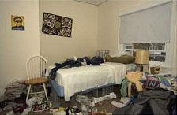
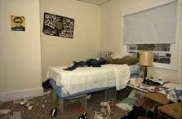
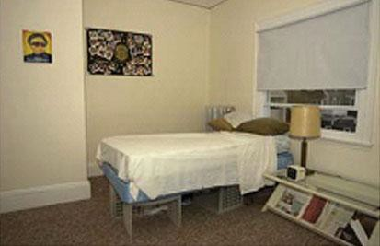

1 2 3

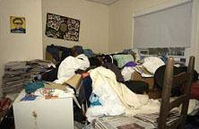
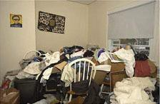
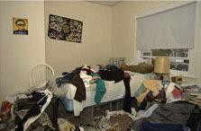

4 5 6

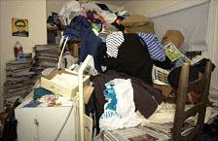
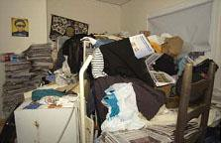
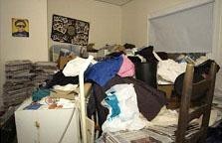

7 8 9

- Clutter Image Rating Scale - Lounge

Please select the photo that most accurately reflects the amount of clutter in the room

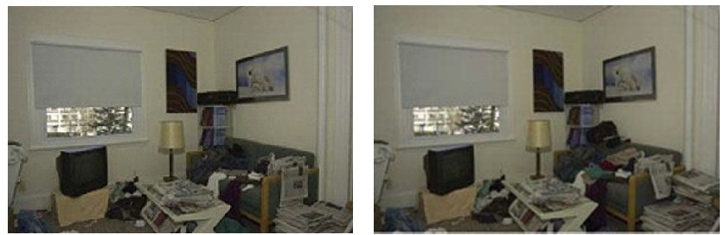
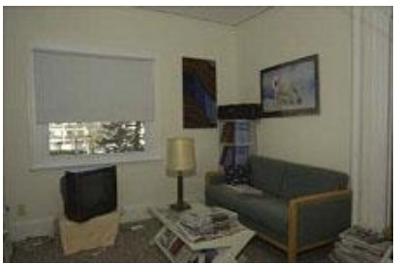

1 2 3

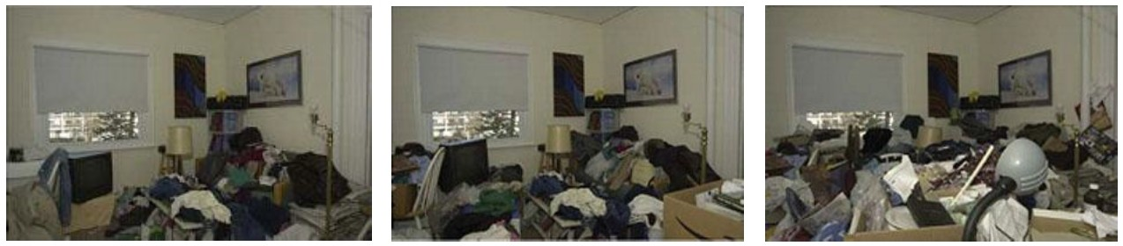

4 5 6

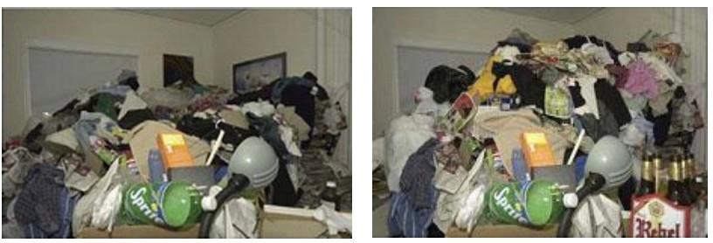
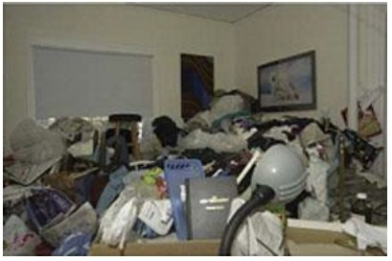

3. Clutter Image Rating Scale - Kitchen

Please select the photo that most accurately reflects the amount of clutter in the room

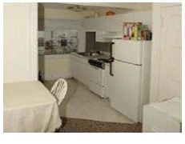
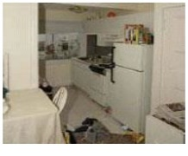
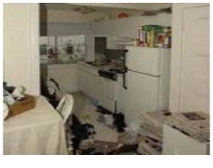

1 2 3

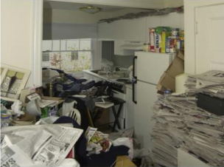
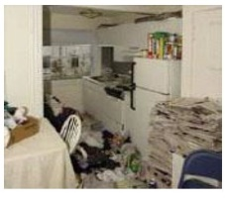
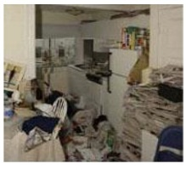

4 5 6

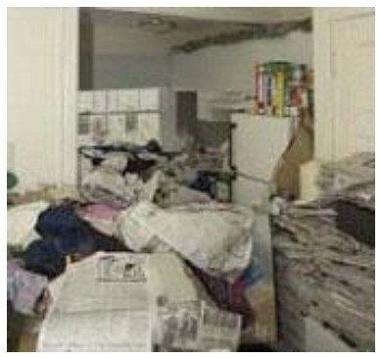
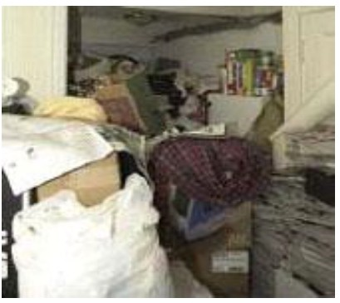
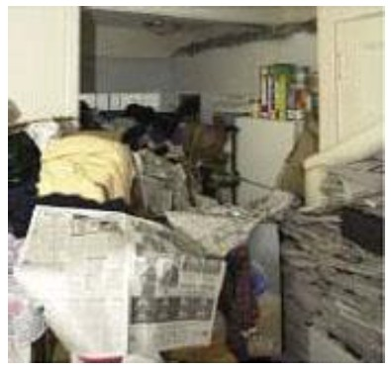

Telford and Wrekin Safeguarding Partnership would like to thank the London Borough of Merton for allowing the reproduction of their Clutter Image Rating Tool.

APPENDIX 4 – TWSP Multi-Agency Hoarding Conference Meeting Agenda Template

Telford and Wrekin Safeguarding Partnership
Multi-Agency Hoarding Conference Meeting
Name:

Held at:

Welcome, Introductions and Apologies

- The Purpose of the Meeting

- Background Information including Risks / Issues / Concerns / Views of the person / support network in place and involved?

- General Discussion; What has been done already and by who, are there any barriers to engagement?

- Timeline - Any engagement issues? What’s helped?

Action Plan – what is the best plan of care to support the person now?

- AOB – are any legal responses needed?

- Date Of Next Meeting, if required

APPENDIX 5 - Useful Contacts
Family Connect – Adults and Children  Early Help & Support Locality Teams  Drug and Alcohol Rehabilitation Service  Telephone: 01952 385385  Out of hours Emergency: 01952 676500  Email: familyconnect@telford.gov.uk  www.familyconnecttelford.co.uk/ | Telford & Wrekin Safeguarding Adults Board  Southwater Square  Southwater One  Telford  TF3 4JG  Email: partnerships@telford.gov.uk  www.telfordsafeguardingpartnership.org.uk
Midlands Partnership NHS Foundation Trust  Jordan House  Hall Court  Telford  Telephone: 0300 124 0365  Email: access.shropshire@sssft.nhs.uk | Telford & Wrekin Public Protection Team  Darby House  Lawn Central  Telford  Tf3 4JA  Telephone: 01952 381999  Email: tradingstandards@telford.gov.uk
Telford & Wrekin Safeguarding Children Board  Addenbrooke House  Ironmasters Way  Telford  TF3 4NT  Telephone: 01952 383924  Email: LSCB@telford.gov.uk  www.telfordsafeguardingboard.org.uk | TACT  Strickland House,  The Lawns  Wellington  Telford  TF1 3BX  Telephone: 01952 899204 or 01952 899205  Email: info@tacteam.org.uk  www.tacteam.org.uk
Aquarius STARS  Glebe Centre  Glebe Street  Wellington  Telford  TF1 1JP  Telephone: 0300 4564291  Email: TelfordAndWrekin@aquarius.org.uk | Telford MIND  Court Street Medical Practice  Court Street  Madeley  Telford  TF7 5EE  Telephone: 07434 869248  Email: talk2@telford-mind.co.uk
THRIVE – Floating Support  Stay (Thrive)  Morson House Office  14/16 Market Street  Oakengates  TF2 6EL  Telephone: 01952 504325  Email: thrive@staytelford.co.uk  www.inspire2thrive.co.uk | THRIVE – Accommodation Support  (Thrive) YMCA Wellington And District  Consort House, Victoria Avenue  Wellington, Telford  Shropshire  TF1 1NH  Telephone: 01952 400401  Email: thrive@ymcawellington.co.uk  www.inspire2thrive.co.uk
Fire Service
Telford Fire Station
Stafford Park 1
TF3 3BW Telford
United Kingdom
Shropshire

Telephone: 01743 260 200
To arrange a safe and well visit telephone 01743 260 260

www.shropshirefire.gov.uk

APPENDIX 6 – Useful Websites
Compulsive Hoarding  Website based service which provides a resource of up-to-date information about compulsive hoarding, its diagnosis, research, treatment and the available support.  www.compulsive-hoarding.org/index.html | Help for Hoarders  Provides information, support and advice for hoarders and their families, including online support forums.  www.helpforhoarders.co.uk
OCD-UK  Provides information and support about Obsessive Compulsive Disorder, which includes hoarding.  http://www.ocduk.org/hoarding | Hoarding UK  Provides information, support for hoarders and agencies, including local support groups.  www.hoardinguk.org
The Association of Professional  De-clutterers & Organisers (UK)  Professional network of those in the  de-cluttering and organising industry.  http://www.apdo.co.uk | Cloud’s End CIC  Resources to help hoarders and housing associations deal with hoarding.  http://www.cloudsend.org.uk/

Taken from the West Midlands Regional Safeguarding guidance on Self-Neglect: https://www.safeguardingwarwickshire.co.uk/safeguarding-adults/i-work-with-adults/west-midlands-regional-safeguarding-information-hub
https://www.mentalcapacitylawandpolicy.org.uk/executive-capacity-and-the-court-of-protection/
https://www.scie.org.uk/mca/directory/forum/nmc-webinars/executive-dysfunction Executive dysfunction and the MCA
Further information can also be found ICD-11 for Mortality and Morbidity Statistics (who.int)

