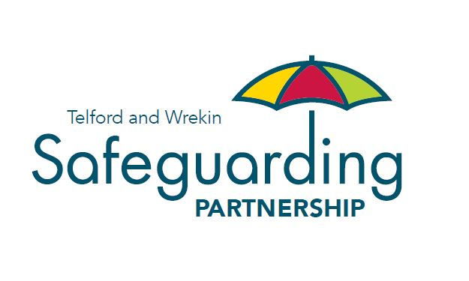

Safeguarding Adults Partnership Arrangements for Telford and Wrekin

The Safeguarding Adult Board places people at the heart of everything we do, to enable people to take control of their lives and decisions and to remain as independent and healthy as possible, for as long as possible. The Board recognises its responsibility to protect adults from abuse and neglect, to reduce the risk of abuse and to support adults in our area to stop abuse with effective responses where it happens.

We will work with, coproduce and listen to, our diverse community to create a positive, inclusive safeguarding culture which does not tolerate abuse and continue to take proactive steps together to prevent harm from occurring to the people of Telford and Wrekin. We seek to ensure that our safeguarding partners work to the principles of ‘Making Safeguarding Personal’ guided by people recognising their preferences, histories, circumstances and life-styles.

This document sets out the partnership arrangements to ensure that we develop strong and effective partnerships while also recognising the different legislation and requirements for adults safeguarding. We will continue to challenge each other to do better, to learn and to aspire for the best outcomes for adults who need our support and protection.

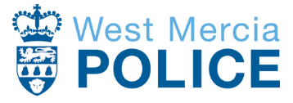

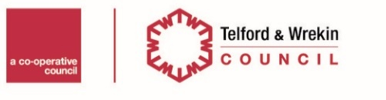

Contents

Introduction 3

Telford & Wrekin: The Community 4

Statutory Responsibilities 4

Principles and Values 6

Structure 6

Governance & Oversight 9

Independent Challenge and Scrutiny 9

Voice Of Our Communities 10

Partnership Support and Management 10

Telford & Wrekin Safeguarding Partnership Budget 10

Dispute Resolution & Whistleblowing 11

Introduction

The Telford and Wrekin Safeguarding Partnership (TWSP) is a statutory and multi-agency partnership. We are determined to ensure that people rather than policies or processes are at the heart of our work and drive what we do. Telford & Wrekin Council, West Mercia Police and Telford & Wrekin ICS (health partners) have a statutory duty to put in place multi-agency safeguarding arrangements to protect and safeguard adults at risk due to their care and support needs. This responsibility is delivered by the Telford & Wrekin Safeguarding Adults Board which is equally funded, by the three statutory partners
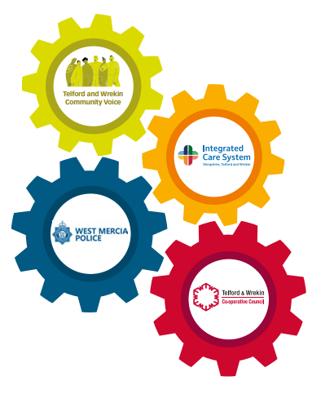
We believe that the voice of Telford and Wrekin people is crucial in understanding how well the Safeguarding Adults Board is meeting their statutory duties and whether services are meeting the needs of Telford people.
Additional membership of the Safeguarding Adults Board is drawn from:
• Shropshire Community Health NHS Trust
• Making It Real Board
• Shrewsbury and Telford NHS Hospital Trust
• Healthwatch
• Midlands Partnership NHS Foundation Trust
• Chief Officers Group
• Partners in Care

Together we hold each other to account and learn through identifying best practice and areas which need development to improve the quality of life of residents within Telford and Wrekin and to ensure continued freedom from harm. In addition to our local partners Telford and Wrekin Safeguarding Partnership is in regular contact with our counterparts up and down the country. We all proactively share learning and good practice.
This document sets out the working arrangements for the Telford & Wrekin Safeguarding Partnership to discharge the statutory responsibilities of “the 2014 Care Act. It includes:

- An overview of the community which the partnership serves
- A summary of the relevant legislation;
- The values and principles that the partnership has adopted
- An overview of the structure of the partnership
- Terms of reference of relevant meetings.
These multi-agency safeguarding arrangements are reviewed periodically in response to changes in legislation and local need.

Telford & Wrekin: The Community

The borough which the Safeguarding Adults Board serves is a place of contrasts. Central to the borough is the new town of Telford which was commissioned in 1968, and grew rapidly around existing communities including Wellington, Oakengates, Dawley and Madeley. Along the banks of the River Severn is Ironbridge, the birthplace of the industrial revolution and now a World Heritage site. Outside of our communities, Telford is surrounded by a rural environment which accounts for more than two thirds of the borough’s area.
The 2021 Census estimated the population of the borough to be 185,842 people. A quarter (45,504 people) are aged 0 to 19. From the 2011 to 2021 Census, the borough’s overall population increased by 19,000 people – an increase of 11% - making it the fastest growing area in the West Midlands. As the population grows it is becoming more diverse and ageing, between 2011 and 2021, the number of people aged 65+ grew by 36% which is twice the regional rate of 18%.

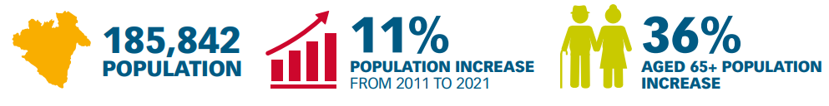
Telford offers exceptional employment and housing opportunities. We also have many schools, beautiful rural retreats, museums, activities, a flourishing shopping centre as well as local hubs, and the additional bonus of excellent commutability to all areas of the United Kingdom with our extensive rail and road networks. However, the Index of Multiple Deprivation shows that there are 18 neighbourhood areas in the borough which are ranked amongst the 10% of the most deprived in England. This may impact upon life experiences of these residents in terms of poorer outcomes with regards to health for example. Such challenges have undoubtedly increased due to the current cost of living crisis

Statutory Responsibilities

Adults Multi Agency Safeguarding Arrangements - Care Act 2014
The Care Act 2014 sets out a clear legal framework for how local authorities and other parts of the system should protect adults at risk of abuse or neglect. Local authorities have safeguarding duties. They must:
- lead a multi-agency local adult safeguarding system that seeks to prevent abuse and neglect and stops it quickly when it happens;

- make enquiries, or request others to make them, when they think an adult with care and support needs may be at risk of abuse or neglect and they need to find out what action may be needed;

- establish Safeguarding Adults Boards, including the local authority, NHS and police, which will develop, share and implement a joint safeguarding strategy;

- carry out Safeguarding Adults Reviews when someone with care and support needs dies as a result of neglect or abuse and there is a concern that the local authority or its partners could have done more to protect them;

- arrange for an independent advocate to represent and support a person who is the subject of a safeguarding enquiry or review, if required.

Principles and Values
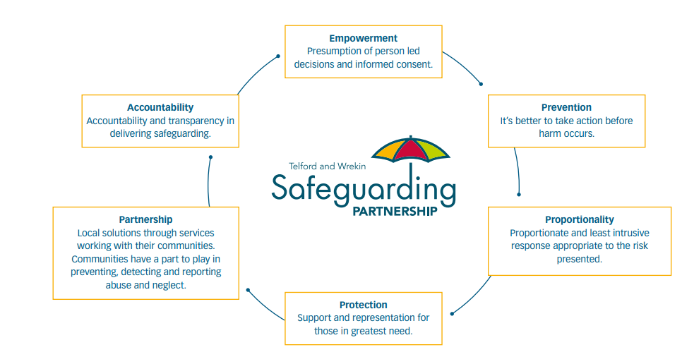

Structure

The Partnership is composed of a separate Safeguarding Children Board and a Safeguarding Adult Board with associated sub-groups to drive the work of each Board.

Priority sub-groups are commissioned by the Boards to drive specific priorities and should be time limited.

Standing sub-groups are implemented to drive Board development and review and learning activities.

Sub-groups are kept under review by each Board to ensure that they are fit for purpose and are driving their relevant business plan.

The structure of each Board is described below.

Board |  | Purpose | Reports to
Adult Safeguarding Board | To develop and drive delivery of local multi-agency safeguarding arrangements to protect and support vulnerable adults. |  | Health & Wellbeing Board, Telford  Health Scrutiny Committee.
Safeguarding Adult Review Panel (Statutory Panel) | To meet the statutory requirements of the Care Act 2104 and conduct Safeguarding Adult Reviews (SARs) to develop learning and inform the work of the ARLT. |  | Safeguarding Adult Board
Adult Review, Learning & Training Subgroup | To promote a culture of continuous multi-agency learning and improvement with our local safeguarding arrangements. |  | Safeguarding Adult Board
Lived Experience, Communication and Engagement Group (Priority Group) | To Improve the way we work with and listen to people representative of all our communities to ensure our work is fully inclusive and reflective of their views and experiences |  | Safeguarding Adult Board
Data Group  (Priority Group) | To improve how data and intelligence is used is part of the Board’s assurance framework for the development of its strategic priorities and targeted service provision. |  | Safeguarding Adult Board
Domestic Abuse Local Partnership Board | To develop and deliver a Telford and Wrekin Domestic Abuse Strategy, which is intelligence-led and based on local needs gathered through a needs assessment. In doing this, the Board will have due regard to the 2021 Domestic Abuse Act which requires the strategy to make arrangements for the assessment of, and the need for accommodation-based support. |  | Safeguarding Adult Board, Safeguarding Children Board and the Community Safety Partnership

Diagram A sets out the structure of the Safeguarding Partnership and its links with other key local partnerships.

Diagram A: Telford and Wrekin Safeguarding Adults Partnership Arrangements

Health & Wellbeing Board

Domestic Abuse Local Partnership Board
Community Safety Partnership (Safer Telford and Wrekin) Board
Safeguarding Children Board

Safeguarding Adults Board

Lived Experience, Communication and Engagement Group
Adults Review, Learning and Training Group

Safeguarding Adults Data Group

Safeguarding Adult Review Panel

Governance & Oversight

The Safeguarding Adult Board has a ‘living strategy’ which allow us to continually review and refine our priorities based on data to respond to emerging risks within our communities. The strategic plan is reviewed annually and published on the Partnership website following a specific annual planning Board session being held to undertake this review jointly with partners. Alongside the living strategy, the Safeguarding adults Board will publish an annual report setting out how it has delivered against its priorities and the progress made in ensuring that multi-agency safeguarding arrangements are effectively protecting vulnerable adults.
The contents of the strategy are shared with the Safeguarding Children Board, the Community Safety Partnership, Health & Wellbeing Board and Domestic Abuse Local Partnership Board to ensure consultation takes place on the contents of this plan to ensure there is clarity of priorities and that there is a shared understanding of how the wider partnership system is progressing as a whole to protect all vulnerable residents within the borough.
Each report will be shared with the other Safeguarding Board, Community Safety Partnership, Domestic Abuse Local Partnership, Corporate Parent Strategic Group and Health & Wellbeing Board and presented to the relevant Scrutiny Committee of the Council. The reports will be published on the Safeguarding Partnership website.
The Safeguarding Adults Board has a risk register identifying risks to the delivery of multi-agency safeguarding arrangements.

Independent Challenge and Scrutiny

The partnership will seek independent challenge through:
- Multi Agency Case File Audits – to drive learning and assess the impact of policy and practice development, each Board will agree an annual programme of such audits which will be independently chaired where appropriate.

- Case Reviews – to drive learning and improvement, local safeguarding practice reviews will be independently chaired.

- Independent Chair - the Adult and Children Safeguarding Boards will each be independently chaired. This role for each Board will also fulfil the role of Independent Scrutineer.

- Annual Report - the Adult and Children Safeguarding Boards will publish and present to Scrutiny an annual report setting out:
  - the work of the partnership and partner agency is to safeguard vulnerable children and adults.
  - progress on agreed priorities.
  - the implementation of recommendations from any national and local practice reviews and their impact.
  - how feedback from children and families have informed the work of the Partnership and agencies.

Voice Of Our Communities

Making it Real Board
“Making Safeguarding Personal” is our approach to ensuring the views of vulnerable adults inform our processes and the outcomes we are seeking to deliver. The key focus is on developing a real understanding of what people wish to achieve.
Our Making It Real Board was set up in January 2018 and is made up of people who use adult services or who are interested in the development of Adult Social Care (ASC) in Telford and Wrekin. The Board works in co-production with council leaders, making recommendations on how different service areas can improve and develop, with the aim of seeing services progress towards more person-centred, community-based support. As 'experts by experience' the Board is uniquely placed to ensure that council leaders are kept in touch with the day-to-day realities for people who use services and their carers and that local people are placed at the heart of decisions around the future of ASC in the borough.

Partnership Support and Management

The work of the partnership will be supported by the Partnership Team. The team supports a range of statutory boards and partnerships. It is funded from the Safeguarding Partnership budget with additional contributions from Telford & Wrekin Council.

Telford & Wrekin Safeguarding Partnership Budget

The Safeguarding Partnership have an agreed budget of composed of contributions from:
- West Mercia Police £63,300
- Telford & Wrekin Council £63,300
- Telford & Wrekin NHS Integrated Care System £63,300

Dispute Resolution & Whistleblowing

There may be occasions where one professional disagrees with the actions of another professional. To resolve these situations, the partnership has adopted an Escalation Policy which should be followed. The Policy sets out clear steps to be taken, who should be involved and the timescale for such action.

The Escalation Policy can be found on the Partnership website here

