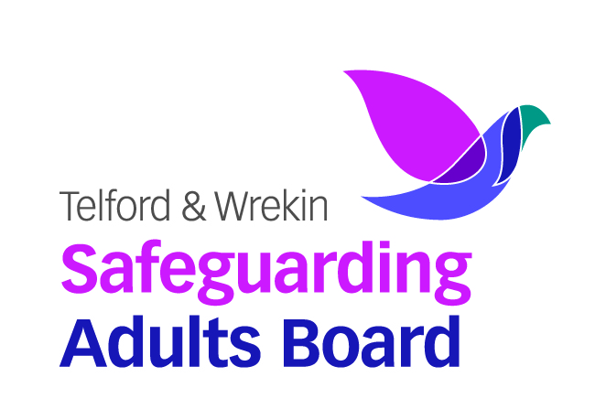
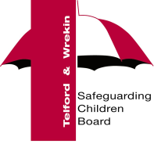

Volunteer Request for an account on Ollie

Completion of this form will register the named individual with the Telford & Wrekin Council’s online learning portal – Ollie.

You will receive confirmation when the account has been set up.

First name
Surname
Email address
For internal audit purposes and generic support the individual must be connected to and employee within TWC
Name of TWC contact
How long will this account be required?
Confirm Job/ Volunteer Role:
Health Champion
Voluntary Youth Worker
Community Centre volunteer
Community Connector
If none on the above, please state:
If member of a voluntary organisation please give contact details
Name of voluntary organisation
Contact address for organisation
Lead contact name for organisation
Email contact address

The account will last for 12 months from activation. After this time, if the individual requires further access they will have to request for their account to be reactivated.
The new user should check their browser settings to allow pop-ups from the site to ensure the courses load correctly.

Privacy Statement – what we will do with the information you provide to us

Telford & Wrekin Council Safeguarding Children Board and Learning and Development team are collecting your personal data to enable you to be able to complete eLearning and face to face training to support your role under Article 6(1)(b) of the General Data Protection Regulations 2018 or equivalent United Kingdom legislation. Telford & Wrekin Council will not share any of your personal data collected with external organisations unless required to do so by law. However, for further details on the council’s privacy arrangements please view the privacy page on the council’s website page.

