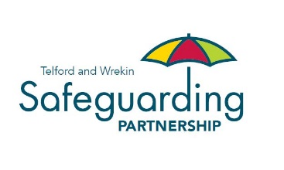

COVID-19 is a new illness that can affect your lungs and airways, which is caused by a virus called Coronavirus.

**You must stay at home** if you have either:

* **A high temperature** – this means that you feel hot to the touch on your chest or back
* **A new, continuous cough** – this means coughing a lot, for more than an hour, or three or more coughing episodes in 24 hours. If you usually have a cough, it may be worse than usual

For further information, please visit the Telford & Wrekin Council website via <https://www.telford.gov.uk/info/20692/coronavirus_covid-19>

**Safeguarding adults and children during the Coronavirus (COVID-19) emergency**

If you need help with shopping or collecting medications, try and use existing and trusted community groups, or trusted family members, friends or neighbours.

**Never give your personal details, including bank cards and pin numbers, to anyone, including those who do your shopping.**

If you are not sure about an offer of help, do not answer the door! Ask the person to leave their details, and tell someone that you trust.

Report your concerns to **Family Connect** on **01952 385385**.

**If there is a threat of immediate danger, always dial 999.**

Safeguarding people means protecting the most vulnerable from abuse and neglect. Abuse and neglect can happen in different ways and be perpetrated by anyone. **Abuse is a crime**.

**If you see something, are told something or something doesn’t feel right, you need to report it!**

You can do this by:

* Ringing **Family Connect** on **01952 385385** from **9am – 5pm, Monday to Friday**
* Ringing the **Emergency Duty Team** on **01952 676500** **after 5pm, Monday to Friday**, and **24 hours at weekends** and **Bank Holidays**

**In an emergency, always dial 999.**