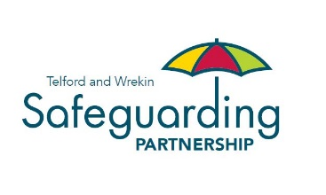

Applying for a training account on Ollie

Full Name
Email address
Job Title

Please indicate your organisation from the following:

Organisation |  | Insert
Clinical Commissioning Group
Community Rehabilitation Company
National Probation Service
Shrewsbury and Telford Hospital NHS Trust (SATH)
Shrewsbury & Telford Hospital NHS Trust – Midwifery
Shropshire Community Health Trust (SCHT)
South Staffordshire and Shropshire Healthcare NHS Foundation Trust (SSSFT)
THRIVE
West Mercia Police
Wrekin Housing Trust
Youth Offending Service
Early Years
Please state organisation name:
Education
Please state organisation name:
SCB Voluntary Sector
Please state organisation name:
Other – not listed above
Please state organisation name

Training is free of charge to Telford and Wrekin Safeguarding Partnership contributing organisations, Local Authority Maintained Schools and volunteers.

Non-contributing organisations will be expected to pay a fee for their training. The Partnership reserves the right to charge at a higher rate for specific bespoke events commissioned from specialise training organisations, these charges will be detailed on advertising flyers for these training events. Further details can be found in the Charging & Cancellation Policy.

If you are a non-contributing organisation, please provide the following billing details:

Name: | Telephone number:
Email address: | Billing address:

For any enquiries, please contact the Partnership Management Team on 01952 384769.

Privacy Statement – what we will do with the information you provide to us

Telford and Wrekin Safeguarding Partnership and the Learning and Development Team at Telford & Wrekin Council are collecting your personal data to enable you to be able to complete eLearning and face to face training to support your role under Article 6(1)(b) of the General Data Protection Regulations 2018 or equivalent United Kingdom legislation. Telford & Wrekin Council will not share any of your personal data collected with external organisations unless required to do so by law. However, for further details on the council’s privacy arrangements please view the privacy page on the council’s website page.

