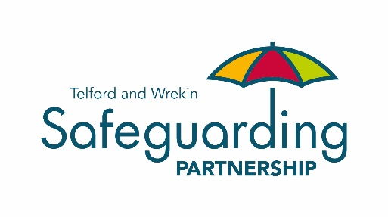

Club Safeguarding Consideration List for Parents, Carers and Clubs

Is your organisation doing everything it can to keep everyone safe whilst attending the club?
The welfare of everyone is paramount, which is why it is important for you as a club to do everything possible to safeguard that individual whilst they are attending the activities run by the club.
The Telford & Wrekin Safeguarding Children and Adults Boards have designed a consideration list to help you assess whether your organisation is fully prepared and doing everything it can to safeguard everyone who is part of your club. If you have not already done so, we would encourage you to use the tool, as it will provide your club with the additional peace of mind that you are doing as much as possible to safeguard everyone, whilst also offering the parent(s)/carer(s) reassurance.
When you are choosing a club for a child, yourself or someone you care for, how do you make sure they/you are safe?
The consideration list is designed to help you to consider the key points and ask the right questions, when choosing a club or activity. This should give you peace of mind and ensure everyone is safe, whilst attending the club.

Should you have any concerns about a Child or an Adult with Care and Support Needs and wish to speak to someone, please contact Family Connect on 01952 385385.

Further Information
NSPCC’s Child Protection in Sport Unit & self-assessment tool
For further information on access levels (thresholds) to services:
- Children Threshold Document
- Adult Threshold Document

Areas for you to consider:
- Policies & Procedures;
- Qualifications & Training;
- Consent;
- Safe Recruitment; and
- Health & Safety.

Together, we can help keep everyone safer

TWSCB& TWSAB Briefing Note – February 2018 FINAL

