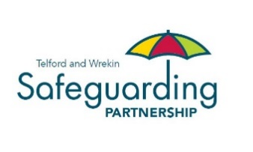
Best Practice Guidance for Responding to Organisational Failure or Abuse

Introduction

If a decline in care standards can be identified early, through effective partnership working, further deterioration in care standards can be prevented that might lead to wider concerns and the need for safeguarding intervention. There is a clear responsibility on commissioners and providers to ensure safe, quality services and an assurance process that will reduce the need for safeguarding interventions.

These guidance notes are relevant to all providers not just those within the scope of CQC inspection regime. The CQC are responsible for inspecting and monitoring providers registered under the Health and Social Care Act 2008. It has statutory powers to inspect how well services are performing against ‘Fundamental Standards’ of quality and safety and can take proportionate enforcement action to ensure providers improve where there is poor care.

These guidance notes explain the process for responding to potential business failure (contracts and commissioning responsibilities) with details of how allegations of organisational abuse are managed where safeguarding concerns are identified. Single concerns may be addressed under Section 42 (safeguarding responsibilities of the Care Act 2014).

Safeguarding concerns in this sense relate to themes or multiple reports of reported abuse or neglect, about one provider, or where a single concern indicates a serious matter that warrants closer inspection under adult safeguarding processes. In some instances, safeguarding action may be initiated following a Safeguarding Adult Review or may run in parallel to one.

The organisational failure or abuse process has become well embedded and has contributed to the co-ordination of multi-agency efforts to address service failures and to hold providers to account where there have been systematic failures.

The organisational failure or abuse process has historically been led by Safeguarding Teams. This has sometimes led to unrealistic expectations regarding the powers of the local authority in relation to its safeguarding role. It has also created an over reliance on safeguarding intervention by other agencies and teams in some cases.

In the majority of organisational failure or abuse, the major concerns are symptomatic of care quality issues or are regulatory in nature and safeguarding concerns have only been a part of the whole picture. Typically, organisational failure or abuse enquiries have identified:
- issues of leadership;
- lack of supervision;
- poor care planning;
- risk management;
- staffing;
- clinical care (e.g. pressure ulcers);
- communication;
- financial management;
- selection and assessment;
- consideration of the compatibility of the service users within the service setting;
- staff training;
- infection control;
- medication; and
- poor moving and handling.

An alternative approach must be found given the clarity in the Care Act Guidance that says “safeguarding is not a substitute for:
- providers’ responsibilities to provide safe and high quality care and support;
- commissioners regularly assuring themselves of the safety and effectiveness of commissioned services;
- the Care Quality Commission (CQC) ensuring that regulated providers comply with the fundamental standards of care or by taking enforcement action; and
- the core duties of the police to prevent and detect crime and protect life and property”.

The primary purpose of this framework is to ensure safe service provision and prevent organisational failure.

These Best Practice Guidance notes should be read alongside the West Midlands Framework for Responding to Organisational Failure or Abuse.
https://www.safeguardingwarwickshire.co.uk/wmadultdocs

Six Step Process

The procedures section follows a Six Step Process.

Entry into the process can be at any level, depending on the circumstances. A strategy discussion or meeting to determine each lead agency and chair will be held at each entry level from point 2 upwards.

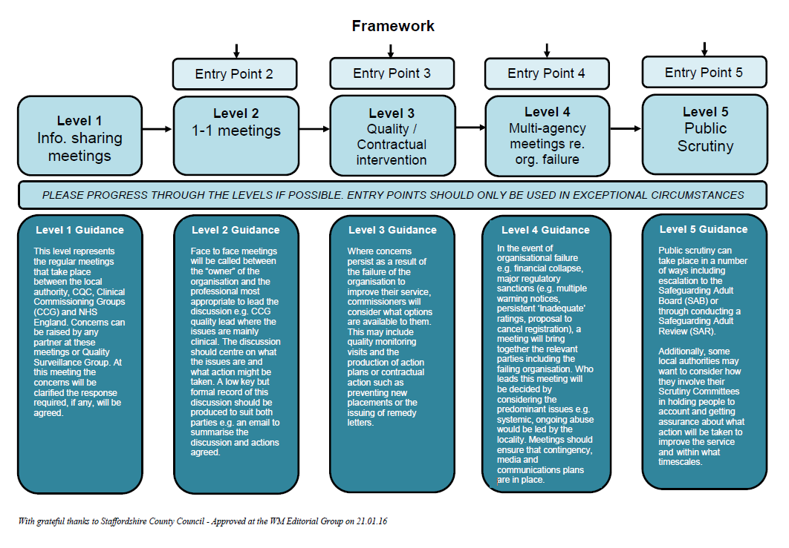

- Level 1: Information Sharing Meetings

This level represents the regular meetings that take place between the local authority, CQC, Shropshire, Telford & Wrekin Integrated Care Board (ICB) and Shropshire and Telford & Wrekin Provider Information Sharing Meeting. Any concerns can be raised by any partner at these meetings or through the Quality Surveillance Group. At this meeting the concerns will be agreed to clarify the response required.

Timescale: Bi-monthly or as required

- Level 2: Initial Provider Concerns Meeting (1:1 meetings)

A low key visit would be undertaken between the responsible individual or the ‘owner’ of the organisation and the professional most appropriate to lead the discussion. The discussion should centre on what the issues are and what action might be taken. A low key but formal record of this discussion should be produced to suit both parties, e.g. an email to summarise the discussion and actions agreed.

The purpose of the visit is to:
- Identify and clarify concerns;
- Ensure appropriate advocacy and support;
- Listen to the views of the provider;
- Safeguarding planning to consider the type of enquiries, leads and timescales;
- Agree informal actions and follow-up;
- Consider commissioning intentions; and
- Set date for Findings Meeting

Meetings with the Provider
The Chair will inform the provider that it is subject to the Provider Concerns process and share as much information as possible, without compromising any subsequent lines of enquiry. They will be informed of the process and provisional timescales if available. If there is a criminal investigation, the provider will be informed in accordance with Police advice.

The Chair and Senior Commissioning Officer should establish regular meetings with the provider, if required. The ethos of meetings should be non-adversarial and promote a culture of partnership ensuring a fair and just process.

- Level 3: Quality/Contractual Intervention

Where concerns persist as a result of the failure of the organisation to improve their service, commissioners will consider what options are available to them. This may include quality monitoring visits and the production of action plans or contractual action such as stopping new placements or the issuing of remedy letters.

The purpose of the meeting is to:
- Assess and agree the findings from ‘Fact Finding’ enquiries.
- Draw up issues for a Service Improvement Plan
- Update the risk management plan and agree safeguarding measures
- Consider actions to monitor the safety of people and agree triggers to escalate risk, whilst improvements are being made
- Consider commissioning intentions
- Preserve information that may be helpful to police investigations

Where immediate action is needed this should be taken and not be put on hold until the Findings meeting. The chair should be informed and immediate authorisation for action is made.

Service Improvement Plan
This is the high-level plan for measuring the effectiveness of interventions to ensure safety, governance, compliance, clinical effectiveness referencing throughout the experience of adults using the service and their informal network. The co-ordinator should set out the concerns and risks, which should also include any concerns in relation to Mental Capacity and DoLs; Mental Capacity Act (2005) and Mental Capacity Assessment Amendment Act (2019). It is important to distinguish between what is safeguarding and what are quality issues that may impact on safeguarding and prioritise high risk areas.

Meetings with the Provider
The chair and lead commissioner (if not the chair) should hold a meeting with the provider as soon after the findings meeting as possible.

The provider will propose actions, leads, timescales and progress to address the concerns within an agreed time. The Service Improvement Plan will be the agreed reference point for assessing and monitoring progress and both the co-ordinator and the provider will retain a copy and update it through a series of monitoring meetings. If there is a Contract Monitoring Officer, commissioner or other relevant member of staff they should be part of these meetings.

In the event that the provider advises that they are unable to make the improvements or of possible service failure or interruptions, a further meeting with all stakeholders should be convened to assess risks and impact on service users to determine commissioning based on the risk and safety of adults using the service.

- Level 4: Multiagency meeting regarding organisational failure

In the event of organisational failure e.g. financial collapse, major regulatory sanctions (e.g. multiple warning notices, persistent ‘inadequate’ ratings, proposal to cancel registration); a meeting will bring together the relevant parties including the failing organisation. Who leads this meeting will be decided by considering the predominant issues e.g. systemic, ongoing abuse would be led by the Local Authority. Meetings should ensure that contingency, media and communications plans are in place.

Further meetings to update stakeholders will be made if and when necessary. Where there are wide reaching, complex concerns, and there is high risk, it is likely that updated meetings are needed more frequently. Where there are serious delays by the provider to implement improvements, a further meeting should always be held to consider the level of risk and appropriate action. Focus should be on risk and the impact on adults using the service. It is important to distinguish between what is safeguarding and what are commissioning responsibilities and if further incidents have occurred.

Where there is a high risk and likely need to source alternative provision, commissioners should hold a specific contingency meeting. The chair and the co-ordinator should be invited.

Communication with adults who use services
Adults who use services should be provided with the opportunity of shaping and influencing the quality of services and be kept central to the process. In a residential setting, adults using services and their families may become anxious about increased activity, seeing more visiting professionals etc., and have the right to be informed, but care should be taken not to raise anxiety. Information sharing should always include adults who use services and their carers so that they are able to make informed choices and retain their independence.

Where there is opportunity for presenting to adults who use the service and carers through a meeting, negotiation with the provider should take place about how this is managed. In those instances where adults receive support at home, as part of the safeguarding plan, care management staff (including Continuing Health Care staff) should make targeted visits to (a) ensure that people are safe and (b) record their views so that they are considered in the organisational risk management plan.

Adults should be provided with the means of sharing their experiences independently of the provider, and if it is deemed necessary a link worker for adults and their families should be identified and a dedicated phone line available to raise issues in confidence.

At the very minimum, checks that the provider has taken action in relation to complaints and acted upon service user surveys should be made.

Communication strategy
The strategy should address both internal and external communications. A check list for information might include:
- Senior Management - Need to Know
- Information to the provider and how on-going communication will be managed
- If a suspension on admissions is considered how this is communicated to front line staff and other commissioners and the public
- Press release
- Briefing for Chief Executives and /or Elected Members
- Consultation with adults who use services, their families and friends
- How information and advice is provided to include adults who fund their own care

Timescale: For further safeguarding meetings are dependent upon progress of the Service Improvement Plan and the level of risk.

- Level 5: Public Scrutiny

Public scrutiny can take place in a number of ways including escalation to the Telford and Wrekin Safeguarding Partnership (TWSP) or through conducting a Safeguarding Adult Review (SAR).

Additionally, some local authorities may want to consider how they involve their Scrutiny Committees in holding people to account and getting assurance about what action will be taken to improve the service and within what timescales.

A quality assurance strategy should be agreed that will rigorously test whether improvements have been attained and can be sustained. This may involve a range of staff with the right knowledge, skills and experience to assess the viability of the improvements and might be the same staff involved in fact finding so that they can provide a comparative narrative.

Quality assurance activities may include testing an on-call emergency out of hour’s system by calling at the evening and weekend; assessing the impact of training by competency testing staff; making both announced and unannounced visits.

Feedback from adults and carers will act as a control measure to assess whether there has been any noted difference in the service delivery. This may be obtained from holding a follow up meeting with adults in care settings or from a sample of telephone calls to those adults who said that they had experienced a poor service, to see if their view has changed.

Support from local Healthwatch may be appropriate, or other locally managed groups for example, Quality Checkers to add an independent view.

Timescale: An agreed timescale will be identified days to complete the quality assurance process should be factored into the strategy

- Level 6: Closing the Provider Concerns process (including level 4 or 5)

Following evidence-based improvement, the process will formally come to an end and the relevant parties including the provider and the CQC will be notified in writing by the chair.

A lessons learnt exercise with stakeholders and representatives from all stakeholders should be held. Feedback from the provider, adults and carers will be collated by the co-ordinator. This feedback will be reported to the TWSP together with a summary report detailing the concerns, actions, risk management, outcomes and the effectiveness of safeguarding.

Assurances should be made that adults and carers know how to raise any further concerns. It may also be helpful to agree a reviewing and escalation process.

Glossary of Terms

Organisational Abuse
Organisational abuse is a broad concept and is not just applicable to high profile cases, for example Winterbourne. It is an umbrella term defined as, ‘the mistreatment or abuse or neglect of an adult at risk by a regime or individual’s within settings and services that adults at risk live in or use, that violate the person’s dignity, resulting in lack of respect for their human rights.’ (Care and Support statutory guidance, 2014ii)

Organisational abuse occurs when the routines, systems and regimes of an institution result in poor or inadequate standards of care and poor practice which affects the whole setting and denies, restricts or curtails the dignity, privacy, choice, independence or fulfilment of adults at risk.

Organisational abuse can occur in any setting providing health and social care.

A number of inquiries into care in residential settings have highlighted that Organisational abuse is most likely to occur when staff:
- Receive little support from management;
- Are inadequately trained;
- Are poorly supervised and poorly supported in their work; and
- Receive inadequate guidance.

Early identification
Hull University (Abuse in Care Project, 2012xcix), identified over ninety individual indicators or warning signs for concern. A summary of factors which can increase the likelihood of abuse occurring within provider settings are drawn from these indicators:
- Management and leadership
- Staff skills, knowledge and practice
- Residents’ behaviours and wellbeing
- The service resisting the involvement of external people and isolating individuals
- The way services are planned and delivered
- The quality of basic care and the environment

Where there is proof of suspicion of organisation abuse by commission, for example the abuse and neglect highlighted in the Winterbourne View and the Old Deanery reports; or omission to provide care and support that puts adults at risk, action will be channelled through the Provider Concerns process.

Principles
- The safety and wellbeing of adults using the service is paramount;
- Strong partnerships that acknowledge the expertise of others;
- Openness and transparency to achieve positive outcomes;
- Joint accountability for risk between commissioners, safeguarding leads, providers, the police, the Local Authority, the ICB and other stakeholders who may be involved;
- Prudent targeted use of resources;
- Information shared responsibly between all agencies, including the provider;
- Co-operation between agencies;
- Natural justice.

How concerns are addressed on level of risk and the impact on people using the service. There are no hard and fast rules, and each case should be considered on its own merit. The process can challenge capacity of one service/organisation therefore it is important that there is a shared approach, breaking down barriers between services and organisations to provide a joined up, one team approach.

Host Authority – The Local Authority in the area where abuse or neglect has occurred.
The host authority is responsible for:
- Liaising with the regulator if any concerns are identified about a registered Provider.
- Determining if any other authorities are making placements, alerting them and liaising with them over the issues in question/under investigation.
- Co-ordinating action under safeguarding and has the overall responsibility to ensure that appropriate action is taken and monitoring the quality of the service provided.
- Ensuring that advocacy arrangements are in place where needed, and care management responsibilities are clearly defined and agreed with placing authorities.
- Ensuring that there is a Chair and the administration of meetings, and provides a clear audit trail of agreements, responsible leads for particular actions and timescales.
- Taking on the lead commissioner role in relation to monitoring the quality of the service provision.

Placing Authority – The Local Authority (or ICB) that has commissioned the service for an individual(s) delivered by a Provider where there is a Provider Concerns.

The placing authority is responsible for:
- Ensuring its duty of care to people it has placed that their needs continue to be met.
- Contributing to safeguarding activities as requested by the host authority, and maintain overall responsibility for the individual they have placed
- Ensuring that the Provider, in service specifications, has arrangements in place for safeguarding.
- Ensuring the placement continues to meet the individual’s needs
- Undertaking specific mental capacity assessments, or best interest decisions for, individuals they have placed
- Reviewing the contract specification, monitoring the service provided and negotiating changes to the care plan in a robust and timely way
- Ensuring all usual care management responsibilities are in place
- Carrying out appropriate assessments under the Deprivation of Liberty Safeguards
- Keeping the host authority informed of any changes in individual needs and/or service provision

The Care Quality Commission (CQC)
The CQC acts independently and is a valued partner in the process of information sharing and working to tackle areas of concern. Their expertise in working with providers and standard setting may support safeguarding processes.

The CQC have the authority to take appropriate enforcement action where providers are found to be slipping but have not yet breached the requirement. This supports CQC’s approach to inspection and enforcement which is based less around compliance of set outcomes, and instead focuses on five key questions about care:
- Is it safe?
- Is it effective?
- Is it responsive?
- Is it caring?
- Is it well-led?

Where there has been a recent inspection it may be helpful for providers to share pre-publicised reports, to support the principle of openness and transparency. In some instances, providers may be addressing issues identified by inspections and adult safeguarding and it makes sense to address both through agreed joint processes.

Lead Agency
The lead agency will be responsible for chairing and co-ordinating the enquiry. The co-ordinator is the appointed member of staff who co-ordinates and undertakes actions and is responsible for documenting and recording. The chair should be a person of seniority with adult safeguarding experience including commissioners.

Local Authority
In most cases, the Local Authority will lead on safeguarding action in consultation with partners and in particular Regulators. The principle on who is best to lead on an enquiry should always be determined by the issue, who the lead commissioner is, and the knowledge and expertise required.

ICB
The ICB may also advise on arranging for clinical expertise in supporting the enquiry, especially where the concern is about health provision, as their clinical knowledge and expertise is likely to be needed. This is to provide a consistent approach to 14.69 of the Care and Support Statutory guidance which states that “When an employer is aware of abuse or neglect in their organisation, then they are under a duty to correct this and protect the adult from harm as soon as possible and inform the local authority.” Before going on to say, “However, a local authority would have to satisfy itself that an employer’s response has been sufficient to deal with the safeguarding issue and, if not, to undertake any enquiry of its own and any appropriate follow up action (for example, referral to CQC, professional regulators). The ICB can therefore provide assistance if there needed to further clinical scrutiny of the clinical findings from the enquiry.

Police
As with all criminal matters the police are the leads and must be consulted about any additional proposed action.

