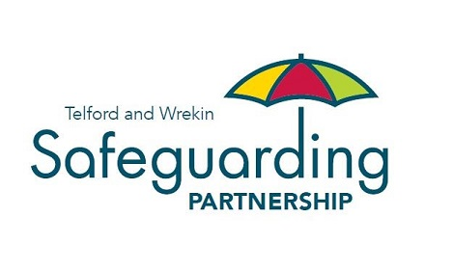

Best Practice Guidance
to
Cultural Competency

Introduction
This guidance is for practitioners across Telford and Wrekin who undertaking assessments, family plans and care planning for adult, children and their families. This guidance was produced following learning identified through Child Safeguarding Practice Reviews
This document is intending to form the basis for culturally competent practice within your organisation, it provides a framework for culturally responsive and sensitive practice, the implementation of the document will differ depending on service area however this provides the basis to consider how to build on these principles within practice.
Definitions

Culture is evidenced in human behaviour and relates to thoughts, communication, actions, customs, beliefs, values and institutions of a racial, ethnic, religious or social group. Culture is not the same as ‘ethnicity’. Ethnicity denotes the origin and membership of a group of people linked for example by language or nationality. This may or may not correspond with a particular culture. Culture is specific to the person, encompassing many facets that have contributed to their individuality, including ethnicity and family values. Culture embraces diversity in its broadest sense and includes differences and similarities due to age, gender, ethnicity, religion and belief, sexual orientation, and disability.
Research in practice defines cultural diversity as being a system of shared beliefs, values, norms, and expectations [which shape] social structures, practices, traditions, and individual’s psychology (including emotions) and social behaviour. “Faith, cultural norms, and even ethnic background may not be immediately obvious. People of similar ethnicities often have different cultures (perhaps because they belong to different age groups or social classes).
Competence means having the capacity to practice effectively when working with families from any ethnic, religious or cultural background. Culturally competent practice acknowledges and incorporates:
- The importance of every family’s culture
- The need for each worker to develop their cultural knowledge and
- The development of services to meet culturally specific needs
Cultural competence is a set of behaviours, attitudes and policies that come together in:
- Our policy and practice in children’s social care
- Our practice in our team
- Our practice with other agencies and services
Failure to explore and respect the reasons behind someone’s behaviour leads to inappropriate and ineffective practice and interactions. Stereotyping operates when assumptions are made about someone based on their culture, ethnicity, or other factors, ignoring variations that exist within and between cultures.
Understanding your own culture and the underpinning values and beliefs that contribute to this is the starting point for acquiring cultural competence. A culturally competent person recognises and responds to individual needs and adapts their practice accordingly. Individuals and employers have a legal responsibility to be culturally competent. An individual’s view upon family life and what is best for their family will be based on their culture and values, and they will interact and respond accordingly.

Cultural Competence in Practice

There are, of course, strong professional and service reasons also for being culturally competent because you then practice effectively. Under the provisions of the Equality Act 2010, public sector bodies have a duty to consider the equality impact of everything they do. There is a requirement on public sector employers to ensure staff receives equality and diversity training to enable them to play their part in fulfilling the general and specific duties outlined, and employers will be expected to monitor staff performance in this area.
There are five essential elements that promote cultural competence in social work practice. These include the ability to:
- Value self-determination, diversity and difference, experience and expertise. Spend some time getting to know the service users, do not rush meetings and interventions
- Be able to recognise how our own cultural identity impacts on others and resist tokenism or simple ‘box ticking’ as a means of evidencing your cultural competence
- Be conscious of how cultures interact and the significance of this in statutory childcare practice.
- Develop cultural knowledge and understanding. Maintain awareness about national and local ethnic, social, and religious demographics and how these are changing
- Contribute to the development of practice in our service that reflects an understanding of diversity between and within cultures
Practice points around these elements:
- practitioners should be aware of their cultural values and biases and how they impact on the helping relationship (this should be explored through supervision, team meetings and ongoing training and development)
- A culturally competent practitioner should understand the worldview and culture of a family. They should have specific knowledge of the cultural diversity of Telford and Wrekin together with knowledge of relevant historical influences (e.g. the impact of war and social unrest in the country of origin). They should also recognise that different families from the same cultural/ religious group may have different beliefs and values. It is always important to ask children and family members what matters to them and not to make assumptions.
- Practitioners should have specific skills and intervention techniques to provide an effective assessment and intervention service which recognises cultural factors in all families. This requires knowledge and understanding of families’ cultural norms, how these influence attitudes to children and whether these accord with statutory child protection principles.
- The Children Act 1989 requires that the welfare of the child is paramount and, whilst an understanding of the cultural context is necessary, this should not get in the way of measures to protect the child from significant harm.
- People of different cultures live and work together. When seeking services and placements to support a child, the ability to meet the child’s needs in the round, including cultural needs, should be the primary driver, rather than the need for a cultural, religious or ethnic match.
Cultural competence should include the ability to:
- Work with all the cultural differences, understand and have basic knowledge of individual cultures from around the world.
- Explore the meaning of culture and belief for families and how this impacts on safeguarding needs.
- Maintain curiosity to explore the meaning of culture and belief for families who appear to share a similar cultural background as the social worker.
- Ask about family beliefs, relationships and values to build a detailed and sensitive picture. The more information and knowledge gained, the more accurate the assessment and analysis of strengths, needs and risks.
- Develop interviewing styles that reflect an understanding of the role of language in a family’s culture. This means developing knowledge of the role of language, speech patterns and communication styles in different cultures.
- Consider strengths as well as areas of need in families and avoid the labelling or pathologising of problems.
- Develop knowledge of the help-seeking behaviours of families which will vary from culture to culture. This entails asking about the family’s preferred support systems; for example religious and spiritual leaders and community support groups.
- Develop knowledge of the history, values, traditions and family systems of cultural groups in Telford and Wrekin
- Develop knowledge of the impact of class, poverty, disadvantage, religious belief and ethnicity on behaviour, attitudes and values.
- Avoid preconceived notions, negative or stereotypical beliefs which risk closing off the search for positive outcomes.
- Explore and analyse the significance of a family’s culture even when the family are from white British culture background.
- Acknowledge that ethnicity and culture affect the way a family communicate, express emotion and shape roles and expectations in their relationships.
- Record the impact of cultural issues, beliefs and values in the assessment and apply it when developing any plan of intervention.
A culturally competent family worker should have:
- Practice qualities that reflect genuineness, empathy and warmth.
- A personal commitment to address discrimination and disadvantage.
- An acceptance and openness to differences among people.
- A willingness to work with children and families, and workers, of different backgrounds.
- An ability to function within the values, ethics and standards of their profession.
- A commitment to develop specialised knowledge and understanding of the history, religions, traditions, values, family systems and languages represented in Telford and Wrekin.
- Knowledge about the services within communities and be able to make appropriate connections with these resources.
The Social GRACES a framework for helping understand aspects of a person’s identity and how they relate to the world around them. They can influence how we see the world and the world see’s us and inform the cultural contexts in which we have personal and professional relationships. By considering Social GRACES this enables practitioners to build awareness of visible/voiced and visible/unvoiced experiences[1]” and also help practitioners consider how their own GRACES, implicit bias, privilege and values might be influencing the relationships and thinking when working with adults, children and families.
They stand for:

Gender
Gender Identity
Geography
Race
Religion
Age
Ability
Accent
Appearance
Culture
Class
Education
Ethnicity
Economics
Sexuality
Sexual Orientation
Spirituality

Child Protection and Cultural Difference

Significant harm to a child physically, emotionally, sexually or through neglect is unacceptable in any culture. Cultural difference in the way families care for their children should be acknowledged and respected. However, it is not acceptable in any culture to allow a child to suffer significant harm.
Where there is a cultural explanation given in relation to significant harm, the social worker should discuss this with their Team Manager.
Thoughts to consider:
- Some cultures use a system of multiple caregivers throughout the first years of a child’s life
- Sleeping arrangements influence early parent-child relationships and may reflect cultural beliefs about infant social development
- Cultures have different ways of responding with the need for dependence and independence. Socialisation methods differ across cultures.
- Assumptions and stereotypes associated with any ethnic or religious group must be reviewed. Asking questions, listening and observing are the basis of all assessments. Each person and family is unique.
Questions to help locate a family’s cultural position
- To what extent is the presenting behaviour and problems related to issues of social transition such as migration, lack of extended family support, discrimination etc?
- Are any behaviours linked to child protection concerns considered “acceptable” within the family’s own culture?
- To what extent are any difficulties in the family a result of lack of access to or knowledge of appropriate resources?
- To what extent is the problem related to cultural conflict within the family around identity, values or relationships of individual members?
Assessing child protection concerns where cultural issues may be a reason/ excuse (e.g. physical chastisement justified through beliefs about child rearing)
- Do the adults in the family see the concerns as a cultural norm?
- Do they want change?
- Does the child see the concerns as a cultural norm?
- Does the child want things to change?
- Does the community see the concerns as an acceptable cultural norm?
- Are there organisations/ people in the community trying to affect change in the family?
- Is there evidence that the concerns will cause significant harm to the child?
- Is there evidence that the concerns are illegal or outside of UK legal parameters?
- All family assessments, intervention plans and contacts should include:
- Identification and analysis of a family’s cultural identity and belief systems.
- An analysis of how this impacts on the family’s ability to safeguard their children.
- An explicit link between the family’s cultural beliefs and any child protection concerns.
This requires analysis of the family’s view of the concerns and whether these accord with wider cultural/ religious values about child up-bringing the family might have.
- An analysis of the family’s engagement with children’s social care and the degree of recognition of our concerns taking in to consideration gender and cultural factors.
- Identification of resources or approaches which are required to assess and respond to the safeguarding concerns in their cultural context. This might include the use of an interpreter, the involvement of a gender specific practitioner or the input from a representative of the family’s cultural community.
Physical Chastisement and Cultural Competence

With regards to physical chastisement, “Children need to be protected irrespective of cultural sensitivities, different practices are no excuse for child abuse taking place” (NSPC 2015).
'Knowledge and understanding of culture and faith is critical to effective assessments of harm through neglect and/or abuse. However, culture and faith should not be used as an excuse to abuse and must never take precedence over children's rights'
Where there is a cultural explanation given concerning physical chastisement, The Children Act 1989 is clear that the welfare of the child is paramount and should remain the focus of any professional intervention. Whilst an understanding of cultural context is necessary, this should not get in the way of measures to protect the child from significant harm.

Abuse Linked to Spiritual and Religious Practices

The belief in “possession" or “witchcraft” is widespread. It is not confined to countries, cultures or religions, nor is it confined to new immigrant communities in this country.
The definition which is commonly accepted across faith–based organisations, nongovernmental organisations and the public sector is the term ‘possession by evil 3 Sharma. N., It doesn't happen here - The reality of child poverty in the UK. 16 spirits’ or ‘witchcraft’. Any concerns about a child which arise in this context must be taken seriously.
Where the concerns relate to several children, consideration should be given to whether the Investigating Complex (Organised and Multiple) Abuse Procedure should be implemented.
Several faith groups have beliefs which affect how they use health services and specifically treatment and immunisations for children. Several churches and faith groups believe in the power of prayers and faith in God and as a result may refuse medical interventions and treatments including assistance at child births, health checks and immunisations. Where a practitioner becomes aware of a belief held by the parents, where it may impact on the health and development of the child, the practitioner should consult with other professionals to assess the potential risks of significant harm to the child.
These issues may also be of concern for adults at risk and referrals should be made into safeguarding adults’ procedures where appropriate.

Faith and Culture Safeguarding Risk Checklist

Families of global majority origin can often live with circumstances that reduce or completely obstruct their ability, with or without a professional support plan, to do the things they need to do to keep their children and adults at risk safe. Ask yourself the following questions to help identify risk factors and seek advice where appropriate:
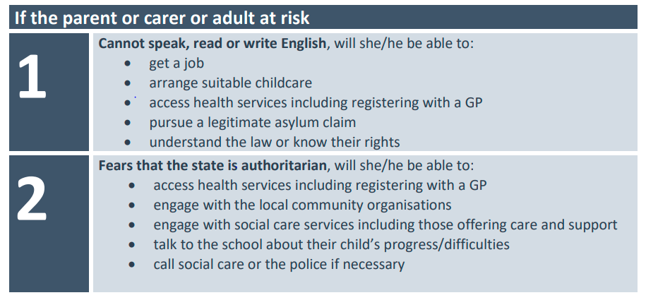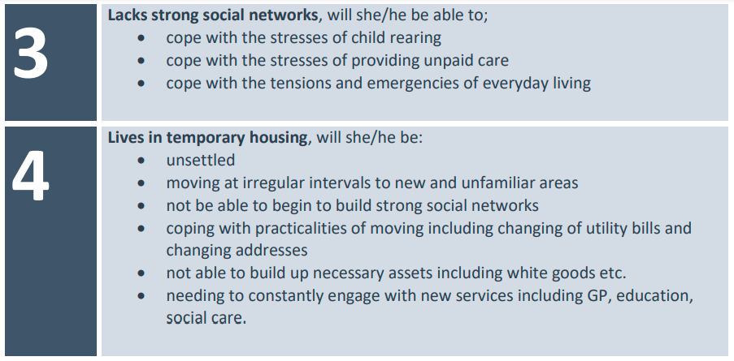
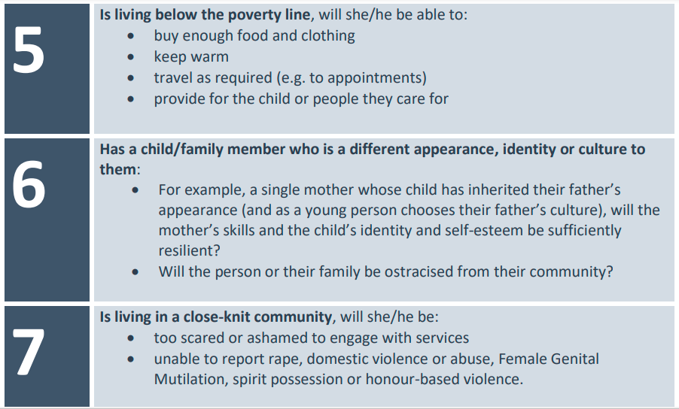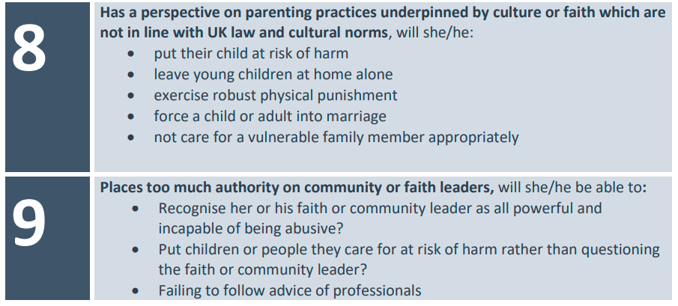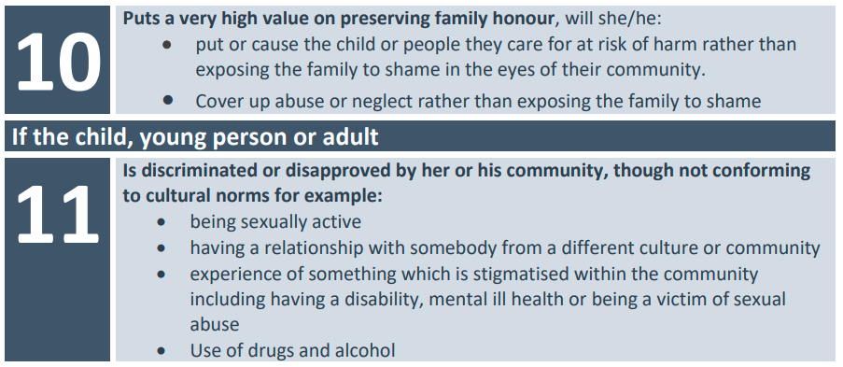
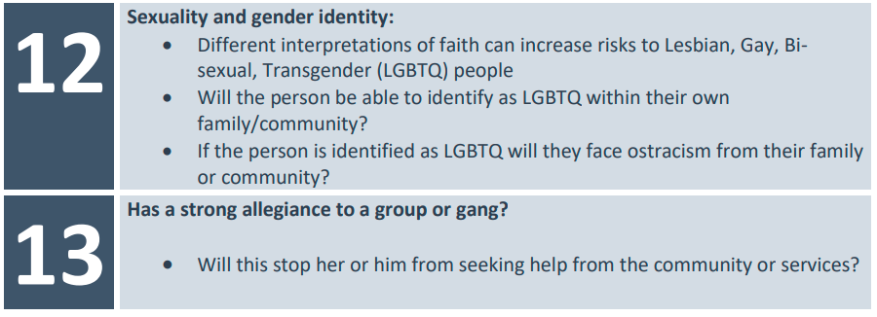

[1] Practice Supervisor Development Programme, 2019). Graces are about process, not a procedure, and therefore take into consideration the interactions between people (BASW, 2020.
Safeguarding Children's Rights Special Initiative: Final Evaluation Report, Tavistock and Portman NHS Foundation Trust / University of East London Centre for Social Work Research, 2011.

