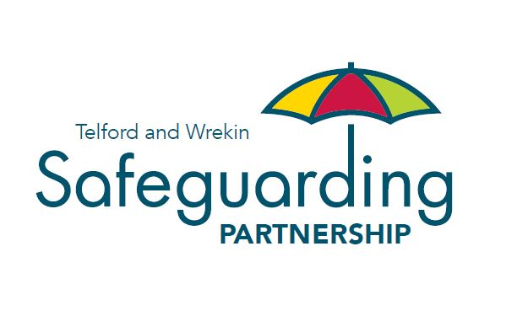

# Telford and Wrekin Safeguarding Partnership

# Modern Slavery Act 2015 Statement

**Reviewed February 2024**

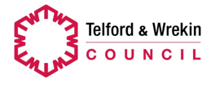 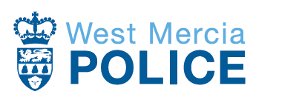 

## What is modern slavery?

Slavery is a violation of a person’s human rights. It can take the form of human trafficking, forced labour, bonded labour, forced or servile marriage, descent-based slavery and domestic servitude. A person is considered to be in modern slavery if they are;

* Forced to work through mental or physical threat
* Owned or controlled by an “employer”, usually through mental or physical abuse
* Dehumanised, treated as a commodity or sold or bought as “property”
* Physically constrained or has restrictions placed on their freedom of movement

## Telford and Wrekin Safeguarding Partnership

As multi-agency Partnerships we have a responsibility to coordinate and monitor the work of agencies in Telford and Wrekin to safeguard and promote the welfare of children, young people and adults with care and support needs.

We aim to ensure that people’s rights are respected in the process of them being offered help and protection.

We work to raise awareness within the wider community, including statutory, voluntary and independent agencies, about how everybody can contribute to safeguarding and promotion of welfare.

The TWSP provide the following statement in respect of their commitment to, and efforts in, preventing slavery and human trafficking practices in the supply chain and employment practices. We will work with our colleague agencies to ensure this commitment is met

TWSP believe there is no room in our society for modern slavery and human trafficking. We have a zero tolerance for modern slavery and breaches in human rights and will ensure this is built into the processes and business practices that we and our partners use.

## Our commitment to prevent slavery and human trafficking

TWSP and all our partners are committed to ensuring that there is no modern slavery or human trafficking in any part of our business activity.

## Our approach

Our overall approach will be governed by compliance with legislative and regulatory requirements and the maintenance and development of best practice in the fields of contracting and employment and we will:

* **Pursue**

Prosecute and Disrupt individuals and groups responsible for modern slavery through the:

* + Utilisation of strong organisations (such as Telford & Wrekin Council, West Mercia Police and the NHS) and effective collaboration;
  + Development and utilization of new and existing resources;
  + Proactive targeting of modern slavery organised crime groups;
  + Attack on criminal finances;
  + Improved capabilities and cooperation with partners;
  + Embedding of the National Referral Mechanism (NRM) process across the partnership in order to increase and maximise its use.
* **Prevent**

Prevent people from engaging in modern slavery of children and adults by:

* + Improving our evidence base on modern slavery offenders;
  + Deter people from engaging in modern slavery through raising awareness of the reality and consequences;
  + Prevent the facilitation of modern slavery;
  + Use interventions to stop people from being drawn in to modern slavery;
  + Utilise both established offender management framework and new tools to deter reoffending;
  + Provide training to front line staff in recognising vulnerable people and provide guidance on how to support them into appropriate pathways and or the NRM.
* **Protect**

Strengthen safeguards against modern slavery by protecting vulnerable people from exploitation and increasing awareness of and resilience against these crimes:

* Protect people at risk of becoming victims;
* Strengthen security and improve ability to detect victims, offences and offenders of these crimes;
* Improve awareness of the signs of modern slavery amongst members of the public;
* Improve partnership awareness of and resilience to modern slavery;
* Develop a partnership intelligence collection plan upon modern slavery to feature at management meetings across the partnership;
* Forge relationships with NGO’s and charitable organisations who support victims of modern slavery and or criminal exploitation, to identify victims and disrupt offenders.
* **Prepare**

Reduce the harm caused by modern slavery through improved victim identification and enhanced support by:

* Proactively identify and recognise victims of modern slavery;
* Provide victims of modern slavery with appropriate and effective support;
* Provide specialist support to child victims of modern slavery;
* Provide specialist support to vulnerable adult victims of modern slavery;
* Support the re-integration of victims into society;
* Support victims and witnesses of modern slavery;
* Ensure effective safeguards to prevent victims being criminalised.

This statement is made pursuant to section 54(1) of the Modern Slavery Act 2015 and constitutes our slavery and human trafficking statement for the financial year commencing 1 April 2024.

## What you can do

Specified public authorities have a duty to notify the Home Office of any individual encountered (England and Wales) who is a suspected victim of slavery or human trafficking. Other organisations, are encouraged to put forward notifications where they encounter a potential victim of modern slavery who does not want to enter the National Referral Mechanism (NRM.

The information that must be provided is set out in the Modern Slavery Act 2015 (Duty to Notify) Regulations 2015: <https://www.legislation.gov.uk/uksi/2015/1743/pdfs/uksi_20151743_en.pdf>.

The information would be provided via the completion of the National Referral Mechanism (NRM) form (where an adult is not consenting to a NRM referral on the online system automatically become a Duty to Notify referral): <https://www.modernslavery.gov.uk/start?hof-cookie-check>

If you identify a potential victim they can be referred to the National Referral Mechanism to be formally identified as a victim of modern slavery and offered Government-funded support.

Referral for potential adult victims is by consent. Government-funded support is provided through a range of specialist providers across the UK.

There is also **Modern Slavery Helpline on 0800 0121 700**.

Also, in England and Wales if an adult victim indicates they require support or safe accommodation please contact the **Salvation Army’s 24 hour referral line on 0300 303 8151.**