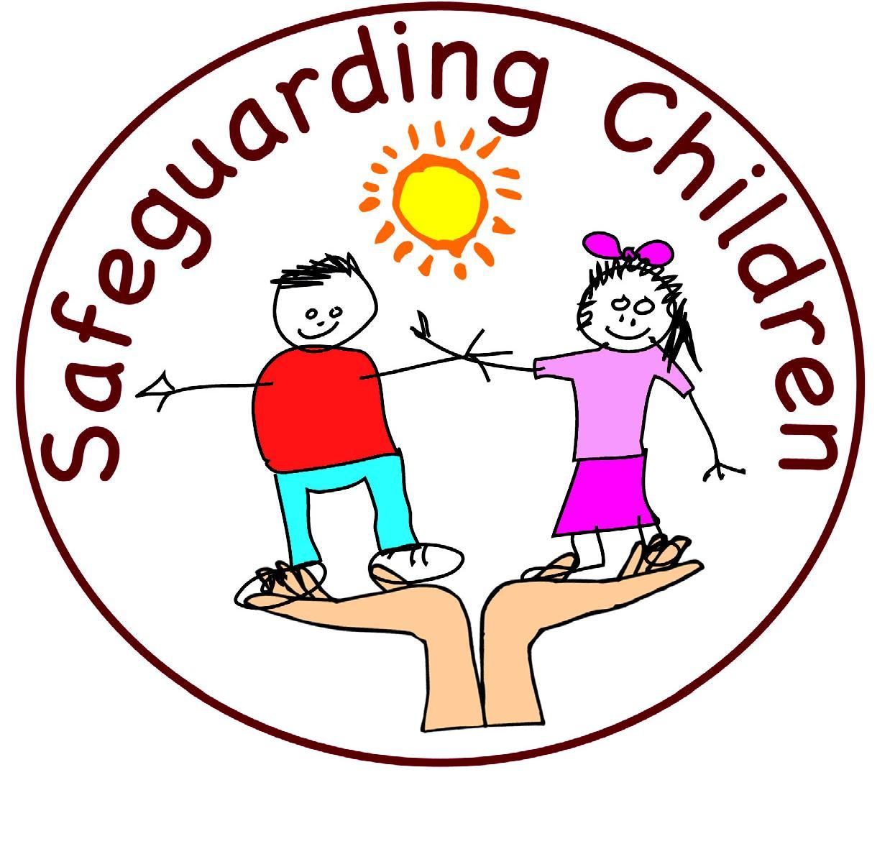 Peer-on-Peer Abuse Quiz for Year 6

Work together to answer the following questions. If you don’t know leave it blank and you can complete the answer when we go through the quiz.
Names in group:

No. | Question | Answer
1. | What is a peer?
2. | Can you briefly describe what abuse is?
3. | What do you understand by Peer-on-Peer abuse?
4. | Can you list the different types of peer-on-peer abuse?
5. | What is sexting?
6. | Can you write a definition for sexual harassment?
7. | If you are in a good relationship, what would you experience?
8. | What might you experience if you are in a bad relationship?
9. | Can you list some of the signs that might indicate someone is being abused?
10. | What would you do if you think you are being subject to peer-on-peer abuse?
11. | Name three adults in school you could talk to.
12. | How can we stop peer-on-peer abuse happening?
13. | What would you do if someone else is subjected to peer-on-peer abuse?
14. | Do you have any questions you would like to ask?
Many thanks for taking part in the Peer-on-Peer Abuse quiz.
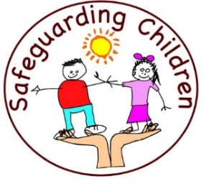
Mrs S. Abdulla

