Peer on Peer Abuse Policy Child-Friendly Version

February 2022



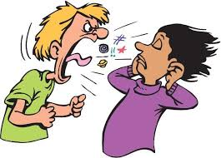

www.teaguesbridgeprimary.org

|  |  |
| --- | --- |
| Written on: | 3rd February 2022 |
| Next Review on: | February 2023 |
| Staff Responsibility | Mrs. S. Abdulla |
| Children responsible | SAs Crew and Year 6 |

**Peer-on-Peer Abuse ~ Child-Friendly Policy**

**2021-2022**

**Contents:**

* **Feeling safe and happy in school**
* **What is Peer-on-Peer Abuse?**
* **Bullying**
* **Sexting**
* **Sexual Harassment**
* **Relationships**
* **How do I know if someone is being abused?**
* **What should I do if I am being abused?**
* **What do I do if someone else is being abused?**
* **Who can I talk to?**
* **How can I help stop abuse from happening?**

**Introduction**

At Teagues Bridge Primary School, we want to make sure that you feel looked after, safe and happy when you are in and out of school. Sometimes we don’t know if something bad is happening, so we need you to tell us.

This policy looks at peer-on-peer abuse and bullying, and what you can do when you feel you are being abused or bullied, or when you notice someone else being abused or bullied. We can help you by:

* Teaching you what Peer-on-Peer abuse is.
* Teaching you what to do if you feel like you are being abused, or if someone else is being abused.
* Making sure you know the grown-ups you can speak to if you are worried.

**What is Peer-on-Peer bullying and abuse?**

A peer is someone who might be your friend, a child at school with you, or another child you may know (may be of a similar age to you).

Abuse is something which usually physically and emotionally hurts another person by using behaviour that is meant to scare, hurt or upset that person. Physical abuse is somebody hurting your body with actions. Emotional abuse is when somebody’s actions affect your mental health in a negative way.

Sometimes, it can be hard to know when abuse is happening, because not all abuse will hurt, scare or upset you, you might not know it is happening. It’s really important you know when you are being abused so we can make sure it stops.

There are lots of different types of abuse. It is important you know what these types of abuse are so you know what to do if you see them or experience them.

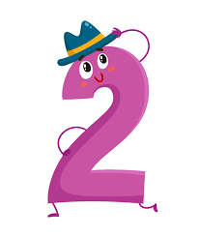

**Bullying**

Bullying can be different things and isn’t just hitting or kicking another person. Unkind actions towards another person that takes place multiple times is classed as bullying.

Emotional bullying is hurting someone’s feelings, leaving them out or bossing them about.

Physical bullying is punching, kicking, spitting, hitting or pushing someone.

Verbal bullying is teasing someone, calling them names or using rude hand signs. People can also use verbal bullying to be racist and homophobic.

Racist means bullying someone because of their skin colour, race or what they believe in.

Homophobic means bullying someone because of their gender or sexuality; calling someone gay or lesbian to hurt their feelings would be homophobic.

Sexist means bullying someone because of their sex (whether they are a boy or a girl).

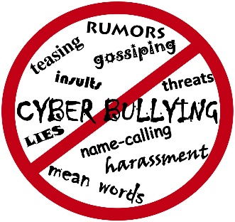Cyber bullying involves sending horrid messages over the internet or by text message. Bullying can be done through another person, by one person sending another person to say nasty things.

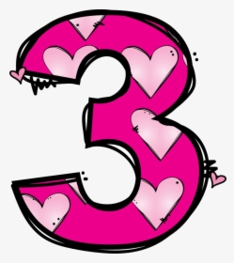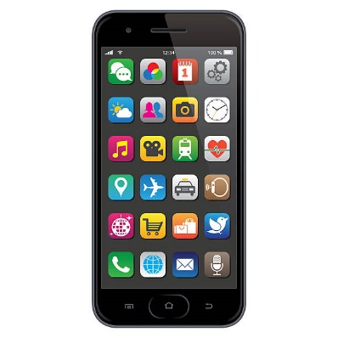

**Sexting**

This is sending inappropriate (not age appropriate) pictures, videos or messages – they can sometimes be called ‘nude pics’, ‘rude pics’ or ‘nude selfies’ (nude means someone with no clothes on), but can also be rude messages. Pressuring someone into sending these kind of pictures, videos and messages is also a type of abuse.

Even if you are not the person who is sending them, it is illegal (against the law) to have these kind of pictures or videos of a person if they are under 18 years old. Even viewing the images makes you guilty of the act.

If an inappropriate image or message is sent to you and you pass it on, this is also illegal (even if you are not the person who took the picture or sent the original image).



**Sexual Harassment**

Sometimes, people can act sexually towards others and it might make them feel uncomfortable and insecure (when someone does not feel happy with their body).

This can happen online on social media, through messages and face-to-face. It might make someone feel scared, embarrassed, uncomfortable, or upset.

It could be:

* Someone making sexual comments, like telling sexual stories, saying rude things or saying sexual things about someone’s appearance or clothes.
* Calling someone sexual names.
* Sexual jokes or teasing
* Being physical, like touching which makes you feel uncomfortable, messing with your clothes, or showing pictures or drawings which are of a sexual nature.
* Being sexual online, like sharing sexual pictures and videos, or posting sexual comments on social media.
* It might also be sexual threats or pushing you to do something sexually that you don’t want to do or aren’t ready for.

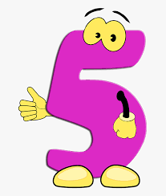**Relationships**

Any relationship you have should be good, happy and healthy.

A bad relationship might make someone feel scared, confused, worried and even unsafe.

It’s really important that you know the difference between a good relationship and a bad relationship.

Good relationship:

* You are comfortable around that person.
* You can be honest with that person.
* You can say how you feel, what you are thinking and you listen to each other.
* You support each other and treat each other nicely.
* You feel safe.
* You trust that person.
* You are equal – you don’t boss each other around or tell each other what to do.
* You feel looked after.

Bad relationships:

* The person might push you, hit you or destroy/ruin your things.
* The person might tell you what to do, what to wear or who you can see.
* You might feel scared, insecure or unsafe – they might say they will hurt you if you don’t do something. They might also say they will hurt you if you do something too.
* The person calls you names, makes you feel bad in front of other people and makes you feel bad about yourself.
* The person gets angry easily and you don’t know what will make them angry – it might make you feel nervous.
* The person might pressure you to do things you don’t want to or aren’t ready for, like sex, or using drugs and alcohol.
* The person might not take no for an answer when you say you don’t want to do something.
* The person may get angry at you and put you in unsafe situations.

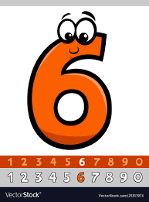

**How do I know if someone is being abused?**

It might be hard for you to know if you are being abused and you might not really understand it is happening. It is important you can recognise when behaviour isn’t appropriate.

It’s also important that you can notice when someone else might be being abused.

Some signs might be:

* Not going to school
* 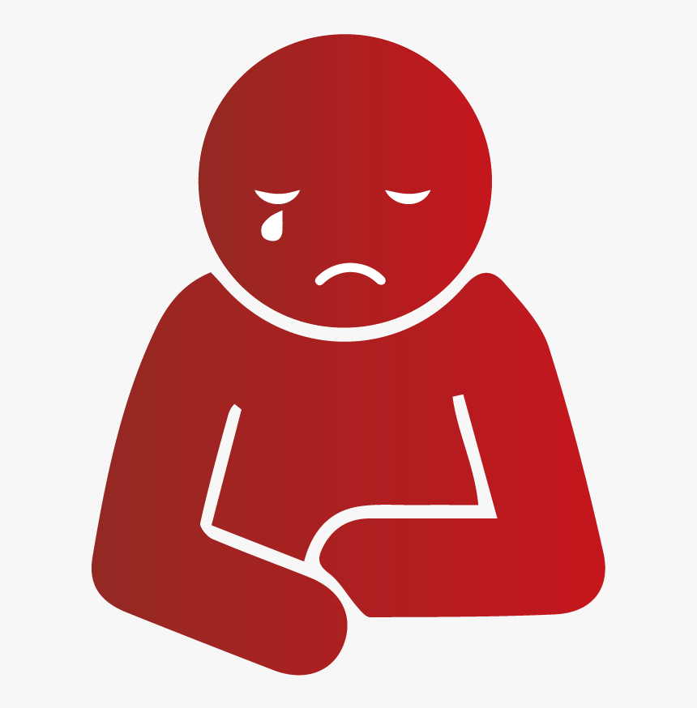Having injuries, like bruises
* Feeling sad and down
* Feeling like they can’t cope (felling like you can’t handle daily life)
* Feeling withdrawn or shy (removing yourself from others)
* Getting headaches or stomach-ache
* Feeling nervous
* Not being able to sleep, sleeping too much or getting nightmares
* Feeling panicked
* Using alcohol or drugs
* Changing looks to look much older
* Changing clothes and looks from what you like to what someone else tells you to like
* Being abusive to someone else.

Remember; you can feel all these things too. Listen to how you feel and know that these signs can mean you are being abused.

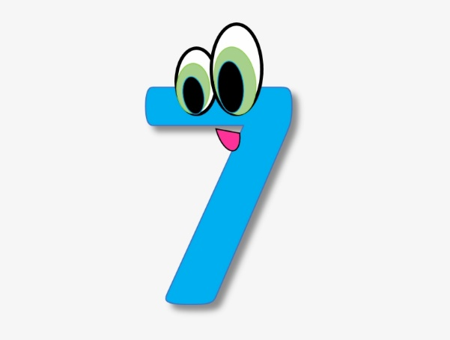

**What Do I do if someone else is being abused?**

If you see someone else being abused, it is important that you **help** that person.

You should **never walk away** and ignore the problem if you see someone else being abused, because the person might keep upsetting them.

If you can, and it is **safe** to do so, tell the person abusing them to **stop**, but never get angry or hit them.

**Tell a grown-up**, such as a teacher as soon as you’ve seen someone being abused.

Grown-ups can **stop the abuse** and make that person feel happy again.

You should **never feel scared** to tell someone about abuse.

Sometimes, you might not **see someone being abused**, but you might be **worried** about them. Or you might think they are being abused by **someone you don’t know**, or someone they have **told** you about. It’s important you **tell someone** even if you are worried but haven’t **seen** any abuse.

If someone tells you they are being abused and asks you not to tell anyone, you must still tell an adult to keep them safe.



**What do I do if I am being abused?**

The first thing you should do is **tell someone you trust**. This could be a family member, a friend or **any adult in our school.**

You can also **tell the person abusing you** to leave you alone. If telling them to leave you alone would **make you feel too scared or worried that they might hurt you**, make sure you **tell someone else** so they can help.

You should **try not** to:

* Do what the person says.
* Let what the person says or does **upset** you.
* Get **angry** or hit them.

Always remember that if you are being abused, it is **not your fault** and you are **never alone**.

You shouldn’t be scared to **talk to someone** if you are being abused. If you talk to a grown-up, we can **make the abuse stop**.

**Who can I talk to?**

It is important you **tell someone** as soon as you are being abused, or you notice someone else being abused.

Speaking to someone like your mum, dad, carer or teacher will mean that we can make sure the **abuse stops** and doesn’t happen again. **The list below shows some of the grown-ups at our school that you can speak to: Mrs Abdulla, Mrs Woods, Mr Hale, Mrs Wilkinson your class teacher, a teaching assistant, a lunch-time supervisor.** If you are too afraid to speak up, you could tell a trusted friend and ask them to tell an adult for you.

You should never be afraid to tell a trusted adult, they will believe you and will do all they can to help you.



**How can I help stop abuse from happening?**

We can all help stop abuse at our school by:

* Making sure we **understand** how we should **act** towards others.
* **Helping** others when they are in need.
* Being **kind**, **friendly** and **respectful** to others.
* Thinking about people’s **feelings** before we say or do something.
* Taking part in **school activities**, like assemblies, PSHE lessons and circle time, which talk about peer-on-peer abuse.
* **Talking to someone** when we are worried.

**You should know that abuse is never OK and it is serious. It is not funny, or**

**part of growing up**. **If you abuse someone, you will get into trouble.**



