Early Help Support Plan for Children, Young People & Families

This Support Plan should always be completed with the Child, Young Person and Family.

If you become concerned that a child/young person is at risk of significant harm, the Telford & Wrekin Safeguarding Partnership Board (TWSP) Multi-agency child protection procedures must be followed. They can be accessed here:

SECTION 1 – About the Person Completing the Support Plan
Start Date of Assessment |  | Date of Support Plan Meeting |  | Support Plan Number
Details of Person Completing the Support Plan
Name
Role
Agency
Address
Email address
Telephone Numbers
Who is the Lead Professional?
Locality

SECTION 2 – Support Plan Family Name
Family Surname(s)
Telephone Number(s)

2.1 Details of any changes in family living arrangements (Living at home or not)
First Name(s) | Surname | Date of Birth or Estimated Date of Delivery (if unborn) | Address | Previous names or aka | Religion | Ethnicity | Relationship | Living in the family home or not Y/N

2.2 Who attended the meeting
Name | Relationship to child/ren | Agency | Contact number

SECTION 3 – Progress made since last Assessment or Support Planning meeting

SECTION 4 – Family Circle Scoring Matrix Scores of below 2 indicate an area of need or concern only score below 2 where needs or concerns have been identified
The family circle will be reviewed every 8 weeks in line with the Early Help support plan. Following discussion around the Family Circle,
please enter the scores for each area in the matrix below:
How many hours have you spent supporting this family since the last Family Circle?

Area | Good Early Years Development |  |  | Getting a Good Education |  | Improved Mental and Physical Health |  |  | Secure Housing
 | Vulnerable expectant or new Parents/ Carers engaging in additional support | Child (0-5) physical health | Child (0-5) developmental needs | Engagement in Education | Child's SEND needs | Young Persons Mental Health and wellbeing | Adult's Mental Health and wellbeing | Physical health for the family | Family in suitable housing, not at risk of eviction | Young person (16-17) in suitable housing, not at risk of homelessness
Practitioner Score
Parent Score
Child Score

Area | Financial Stability |  |  | Promoting recovery and Reducing harm from Substance Misuse |  | Improved Family relationships
 | Adult in work, or progress being made towards work | Managing Finances | Young Person being in Employment Education or Training | Young Persons drug or alcohol problems | Adult's drug or alcohol problem | Positive parenting | Positive family relationships (No harmful parental conflict) | Positive family relationships (No harmful child to adult / sibling conflict) | Young Carers receiving support
Practitioner Score
Parent Score
Child Score

Area | Children are Safe from Abuse and Exploitation |  |  |  |  | Preventing and Tackling Crime |  | Safe from Domestic Abuse
 | Feeling safe (No abuse, neglect or harmful home conditions in household) | Children who are going missing | Children who are experiencing harm outside of the family | Children who are at risk of, or experiencing Sexual Exploitation | Children who are at risk of, or experiencing Criminal Exploitation  (eg County Lines and radicalisation) | Young Person safe from Crime (Not at risk or involved in crime or ASB) | Adult safe from Crime (Not involved in crime or ASB) | Child feels safe at home (No domestic Abuse) | Families affected by DA, having a clear safety plan/support | Adult perpetrator of DA, engaging in support
Practitioner Score
Parent Score
Child Score

Criteria | Relates to | Supporting Comments
Good Early Years Development | Vulnerable expectant or new Parents/Carers engaging in additional support  Child (0-5) Physical health  Child (0-5) Developmental Needs
Getting a Good Education | Engaging in Education  Child’s SEND needs
Improved Mental and Physical Health | Young Persons Mental Health and wellbeing  Adult’s Mental Health and wellbeing  Physical health for the family
Secure Housing | Family in suitable housing, not at risk of eviction  Young Person (16-17) in suitable housing, not at risk of homelessness
Financial Stability | Adult in work, or progress being made towards work  Managing Finances  Young Person being in Employment, Education or Training

Promoting recovery and reducing harm substance misuse | Young Persons drug or alcohol problems  Adult’s drug or alcohol problems
Improved Family Relationships | Positive Parenting  Positive Family relationships (no harmful parental conflict)  Young Carers receiving support
Children are Safe from Abuse and Exploitation | Feeling safe (No abuse, neglect or harmful home conditions in household)  Children who are experiencing harm outside of the family  Children who are at risk of, or experiencing sexual exploitation  Children who are at risk of, or experiencing criminal exploitation (eg county lines and radicalisation
Preventing and Tackling Crime | Young Person safe from crime  Adult safe from crime
Safe from Domestic Abuse | Child feels safe at home (no DA)  Families affected by DA, having clear safety plan/support  Adult perpetrator of DA, engaging in support

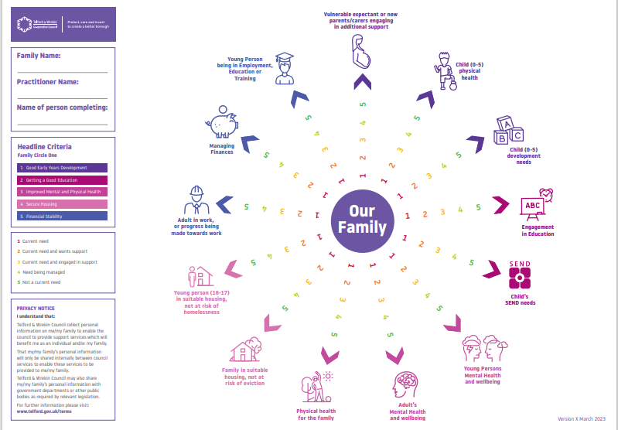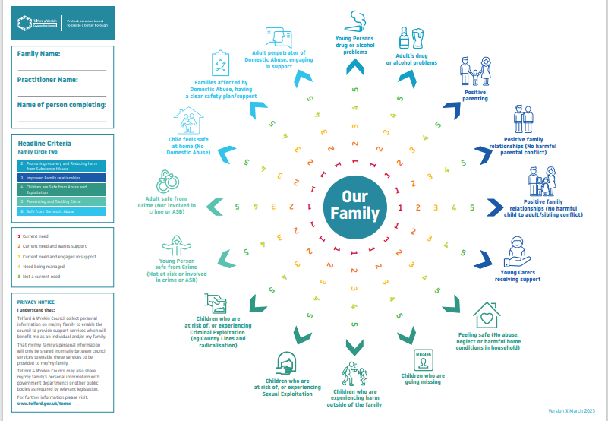
Early Help Support Plan
SECTION 5 – What needs to happen next
What needs to happen in the child, family’s view  and agencies view | Agreed Actions | Outcome | By whom and when

Threshold Guidance Level of Need
Based on information provided, has the level of need changed? Please tick the appropriate box to indicate the current level of need
Universal |  | Vulnerable |  | Complex |  | Acute

SECTION 6 – End of Involvement
Summary
Is this the end of involvement |  | Yes/No – If yes please state reason for closure
Parent/carer informed of closure |  | Yes/No
Child informed of closure? |  | Yes/No
Next Meeting Date |  |  | Time |  | Venue

Privacy Notice under the General Data Protection Regulations 2018
Telford & Wrekin Council [Strengthening Families] are collecting your personal data to enable the best possible advice, care or support to be provided and to meet the statutory requirements under the Care Act 2014, wider legislation and Article 6(1)(c), Article 6(1)(e) and Articles 9(2)(c) & (h) of the UK General Data Protection Regulations 2018.
Telford & Wrekin Council will not share any of your personal data collected with external organisations unless required/permitted to do so by law. However, there may be occasions where we request further information from key third party organisations such as Health or Provider organisations. For further details on the council’s privacy arrangements please view the privacy page on the council’s website page.

This document needs to be forwarded to:
StrengtheningfamiliesBSO@telford.gov.uk

