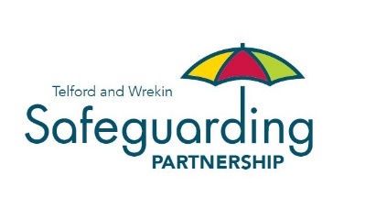

Partner Agency Representation 2023-2024

Organisation
Independent Chair
Telford & Wrekin Council
West Mercia Police
Telford and Shropshire Integrated Care System (ICS)
Shropshire Community Health NHS Trust
Shrewsbury and Telford Hospitals NHS Trust
Midlands Partnership NHS Foundation Trust
Partners in Care
Probation Service
Healthwatch Telford and Wrekin
Wrekin Housing Trust
Severn Teaching Alliance
Chief Officer Group
Making it Real Board
Care Quality Commission
Shropshire Domestic Abuse Service
Telford College
West Mercia Youth Justice Team
Department for Work and Pensions
Shropshire Fire & Rescue Service
Foster Carers Association
West Midlands Ambulance Service
The Children’s Society
West Mercia Police Crime Commissioners Office
Children and Family Court Advisory and Support Service

