Early Help Assessment for Children, Young People & Families

This Assessment should always be completed with the Child, Young Person and Family.

If you become concerned that a child/young person is at risk of significant harm, the Telford & Wrekin Safeguarding Partnership Board (TWSP) Multi-agency child protection procedures must be followed. They can be accessed here:

SECTION 1 – About the person completing the assessment
Start Date of Assessment
Details of Person Completing the Assessment
Name
Role
Agency
Address
Email address
Telephone Numbers
Who is the Lead Professional?
Locality

SECTION 2 – About the family living in the family home
Family Surname (s)
Family Address (including Post Code)
Housing Provider (Name of Landlord)

Telephone Number(s)
Religion

Ethnicity
Nationality
First Language
Details of any disability in the family
Do any of the children have a caring responsibility? | Yes No
Is the child privately fostered? (if yes please provide details)

2.1 Details of each family member or significant people living in the family home
First Name(s) | Surname | Religion  Pick list | Ethnicity  Pick list | Previous names or aka | Relationship  Pick list | Date of Birth or Estimated Date of Delivery (if unborn) | Education, Employment or Training (pick list, ‘employed’, ‘in training/education’ – if selected detail name of school/college/nursery

2.2 Details of any significant people not living in the family home
First Name(s) | Surname | Religion | Ethnicity | Date of Birth | Relationship | Address

2.3 Why is this assessment being completed?

SECTION 3 – Professional Involvement – other agencies and/or professionals currently involved with the family and whether they have contributed to the assessment.
Agency/Professional Name | Address and Telephone Number | Who are they supporting in the family | Contributed to this Assessment  Yes/No

SECTION 4 – Family Circle Scoring Matrix Scores of below 2 indicate an area of need or concern only score below 2 where needs or concerns have been identified
The family circle will be reviewed every 8 weeks in line with the Early Help support plan. Following discussion around the Family Circle,
please enter the scores for each area in the matrix below:

Area | Good Early Years Development |  |  | Getting a Good Education |  | Improved Mental and Physical Health |  |  | Secure Housing
 | Vulnerable expectant or new Parents/ Carers engaging in additional support | Child (0-5) physical health | Child (0-5) developmental needs | Engagement in Education | Child's SEND needs | Young Persons Mental Health and wellbeing | Adult's Mental Health and wellbeing | Physical health for the family | Family in suitable housing, not at risk of eviction | Young person (16-17) in suitable housing, not at risk of homelessness
Practitioner Score
Parent Score
Child Score

Area | Financial Stability |  |  | Promoting recovery and Reducing harm from Substance Misuse |  | Improved Family relationships
 | Adult in work, or progress being made towards work | Managing Finances | Young Person being in Employment Education or Training | Young Persons drug or alcohol problems | Adult's drug or alcohol problem | Positive parenting | Positive family relationships (No harmful parental conflict) | Positive family relationships (No harmful child to adult / sibling conflict) | Young Carers receiving support
Practitioner Score
Parent Score
Child Score

Area | Children are Safe from Abuse and Exploitation |  |  |  |  | Preventing and Tackling Crime |  | Safe from Domestic Abuse
 | Feeling safe (No abuse, neglect or harmful home conditions in household) | Children who are going missing | Children who are experiencing harm outside of the family | Children who are at risk of, or experiencing Sexual Exploitation | Children who are at risk of, or experiencing Criminal Exploitation  (eg County Lines and radicalisation) | Young Person safe from Crime (Not at risk or involved in crime or ASB) | Adult safe from Crime (Not involved in crime or ASB) | Child feels safe at home (No domestic Abuse) | Families affected by DA, having a clear safety plan/support | Adult perpetrator of DA, engaging in support
Practitioner Score
Parent Score
Child Score

Criteria | Relates to | Supporting Comments
Good Early Years Development | Vulnerable expectant or new Parents/Carers engaging in additional support  Child (0-5) Physical health  Child (0-5) Developmental Needs
Getting a Good Education | Engaging in Education  Child’s SEND needs
Improved Mental and Physical Health | Young Persons Mental Health and wellbeing  Adult’s Mental Health and wellbeing  Physical health for the family
Secure Housing | Family in suitable housing, not at risk of eviction  Young Person (16-17) in suitable housing, not at risk of homelessness
Financial Stability | Adult in work, or progress being made towards work  Managing Finances  Young Person being in Employment, Education or Training
Promoting recovery and reducing harm substance misuse | Young Persons drug or alcohol problems  Adult’s drug or alcohol problems
Improved Family Relationships | Positive Parenting  Positive Family relationships (no harmful parental conflict)  Young Carers receiving support
Children are Safe from Abuse and Exploitation | Feeling safe (No abuse, neglect or harmful home conditions in household)  Children who are experiencing harm outside of the family  Children who are at risk of, or experiencing sexual exploitation  Children who are at risk of, or experiencing criminal exploitation (eg county lines and radicalisation
Preventing and Tackling Crime | Young Person safe from crime  Adult safe from crime
Safe from Domestic Abuse | Child feels safe at home (no DA)  Families affected by DA, having clear safety plan/support  Adult perpetrator of DA, engaging in support

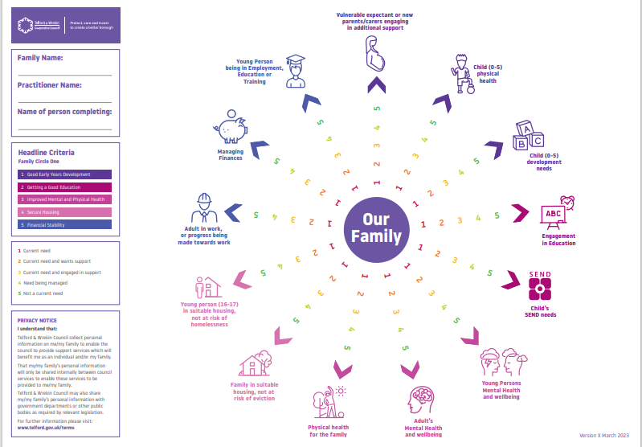

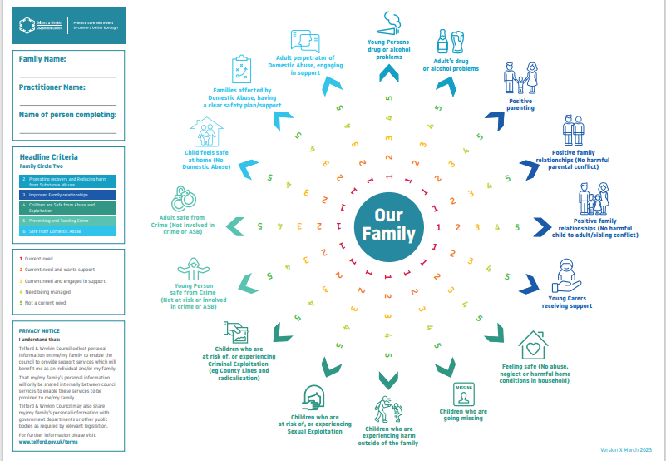

SECTION 5 - Tell us what has led to this assessment.
What are you worried about?  Harm/impairment/ Worries – Past and present harm which has occurred.  Impact on the child  On-going difficulties which are causing the different members of the family to not meet their potential. | Parent/Carer
 | Child/Young person
 | Agency
Complicating factors (including any previous involvements):  What is making this problem harder to deal with? What are the behaviours which increase the worry? What don’t we know? | Parent/Carer
 | Child/Young person
 | Agency
How does the family manage worries and concerns?  What helps the child or family manage, overcome or avoid the worry? | Parent/Carer
 | Child/Young person
 | Agency
What is working well - Existing strengths  What are the best things about the parents and the care of the children? Who supports/help the parents and children?  Comment on the child’s lived experience- what is going well in their life. | Parent/Carer
 | Child/Young person
 | Agency
Community Support Network  What local facilities do you use? I.e., schools, day nurseries, sports, play and Leisure centres, libraries etc.  Any barriers to accessing these services? | Parent/Carer
 | Child/Young person
 | Agency

SECTION 6 – Analysis of Needs and Risk – What is your analysis?
Consider all strengths, unmet and complex needs and risk associated to needs that are not being met and impact on the child.

Early Help Assessment Support Plan

SECTION 7 – What needs to happen next (Note: Focus on the Worry Statements and Risks that need support ie. Domestic Abuse, Neglect, Health issues, School attendance etc..)
What needs to happen in  the family’s and agency’s view | Agreed Actions | Outcome | By whom and when

Threshold Guidance Level of Need – Please tick the appropriate box to indicate the level of need
Universal |  | Vulnerable |  | Complex |  | Acute

SECTION 8. – Outcome of Assessment
What is the outcome of this assessment? | Move to plan (single agency response)  Move to plan (multi-agency repose)  Closed, NFA
Date Involvement Ended
Date of First Early Help Support Plan Meeting
Name of Lead Professional completing the meeting
Family Informed | Yes or no drop down

Privacy Notice under the General Data Protection Regulations 2018
Telford & Wrekin Council [Strengthening Families] are collecting your personal data to enable the best possible advice, care or support to be provided and to meet the statutory requirements under the Care Act 2014, wider legislation and Article 6(1)(c), Article 6(1)(e) and Articles 9(2)(c) & (h) of the UK General Data Protection Regulations 2018.
Telford & Wrekin Council will not share any of your personal data collected with external organisations unless required/permitted to do so by law. However, there may be occasions where we request further information from key third party organisations such as Health or Provider organisations. For further details on the council’s privacy arrangements please view the privacy page on the council’s website page.

This document needs to be forwarded to:
StrengtheningfamiliesBSO@telford.gov.uk

