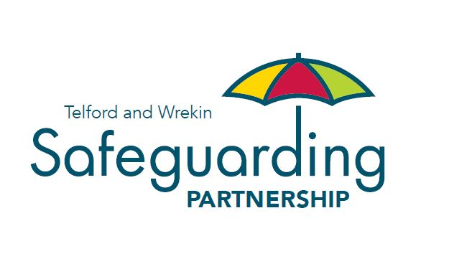

Non-Accidental Injuries Learning Event
01/04/2022 9am-1.30pm

AGENDA

9.00-9.30am | Arrival Tea and Coffee
9.30-9.35am | Welcome from TWSP | Andrew Mason
9.35-10.30am | Guest Speaker Presentation | Dr Blyth
10.30-11am | TWSP Presentation | Andrew Mason
11am-11.30am | Tea and Coffee Break
11.30am-12.30pm | Workshops | Louise Spragg
12.30-1.00pm | Round Up | Louise Spragg
1.00-1.30pm | Closing | Andrew Mason

