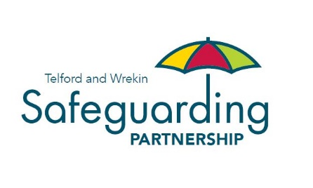

Criteria for a Serious Incident Notification and subsequent Rapid Review

Serious child safeguarding cases are those in which:

- Abuse or neglect of a child is known or suspected and;
- The child has died or been seriously harmed.

Serious harm includes – but is not limited to – serious and/or long-term impairment of a child’s mental health or intellectual, emotional, social or behavioural development. It should also cover impairment of physical health.

If the criteria for a Serious Incident Notification (SIN) is met, this triggers the Telford and Wrekin Safeguarding Partnership to hold a Rapid Review.

Criteria for holding a Child Safeguarding Practice Review

Those present at the Rapid Review have considered whether to carry out a Local Safeguarding Practice Review, and have agreed that the case has the potential to meet the following criteria from Working Together 2018:

Highlights or may highlight improvements needed to safeguard and promote the welfare of children, including where those improvements have been previously identified
Highlights or may highlight recurrent themes in the safeguarding and promotion of the welfare of children
Highlights or may highlight concerns regarding two or more organisations or agencies working together effectively to safeguard and promote the welfare of children
Is one which the Child Safeguarding Practice Review Panel have considered and concluded a local review may be more appropriate
Safeguarding partners have cause for concern about the actions of a single agency
There has been no agency involvement, and this gives the safeguarding partners cause for concern
More than one local authority, police area or clinical commissioning group is involved, including in cases where families have moved around
The case may raise issues relating to safeguarding or promoting the welfare of children in institutional settings
None of the above

